

Introduction To Software Engineering

AAPP003-4-2-ISWE

Group and Individual Assignment

Lecturer Name: Thavamalini A/P Sivasamy

Submission Date: 8/2/2024

|  |  |  |  |
| --- | --- | --- | --- |
| **Group Member** | | | |
| ***No.*** | ***Name*** | ***TP Number*** | ***Intake*** |
| 1 | CHOK JUNG SHING | TP070674 | UCDF2208ICT(SE) |
| 2 | LEW WAI HOW | TP071331 | UCDF2208ICT(SE) |
| 3 | LEONG SENG KHUAN | TP070856 | UCDF2208ICT(SE) |
| 4 | TEH ZHONG CHENG | TP070872 | UCDF2208ICT(SE) |
| 5 | TONG JIA CHUEN | TP070484 | UCDF2208ICT(SE) |

Table of Contents

1.0 Introduction 4

1.1 Background 4

1.2 Business Introduction 4

1.3 Problem Statement 5

1.4 Aim 5

2.0 Planning and Requirement Analysis 6

2.1 Gantt Chart 6

2.2 Workload Matrix 7

2.3 Budget Proposal 7

2.4 Functional Requirements 8

2.4 Non-Functional Requirements 10

3.0 Logical Design Part 1 12

3.1 Use Case Diagram 12

3.2 Class Diagram 14

4.0 Physical Design 16

4.1 Customer 16

4.1.1 Home Page and Login Page 16

4.1.2 Booking Page 16

4.1.7 Inquiries Page 18

4.2 Receptionist 19

4.2.1 Inquiries Page 19

4.2.2 News and Event 19

4.2.3 Manage Billing 20

4.2.4 Manage Booking and Appointment 20

4.2.5 Manage Coach Schedule 21

4.3 Coach 22

4.3.1 View Schedule 22

4.3.2 Write Progress Report 22

4.4 Owner 23

4.4.1 Generate Business Report 23

5.0 Implementation 23

5.1 Hardware 23

5.2 Software 25

6.0 Prototype 27

6.1 Customer 27

6.2 Receptionist 32

6.3 Coach 36

6.4 Owner 39

7.0 Conclusion 41

8.0 Individual Component 42

8.1 CHOK JUNG SHING (TP070674) 42

8.1.1 Activity Diagram (Make Inquiries & Consultation) 42

8.1.2 Waterfall Methodology 43

8.1.3 Functionality Testing (Make Inquiries & Consultation) 47

8.2 LEW WAI HAO (TP071331) 52

8.2.1 Activity Diagram (Login and Register & Payment Processing) 52

8.2.2 Rational Unified Process 54

8.2.3 Security Testing 58

8.3 LEONG SENG KHUAN (TP070856): 65

8.3.1 Activity Diagram (Generate Business Sales Report & Modify Player Progress Report) 65

8.3.2 Boehm’s Spiral model 67

8.3.3 Usability Testing 70

8.4 TEH ZHONG CHENG (TP070872) 74

8.4.1 Activity Diagram (Manage News and Event & Make Booking) 74

8.4.2 Prototyping 76

8.4.3 Load and Stability Testing (Manage News and Event & Make Booking): 78

8.5 TONG JIA CHUEN (TP070484): 84

8.5.1 Activity Diagram (Receptionist Manage coach schedule and Receptionists reply customer inquiry) 84

8.5.2 Rapid Application Development (RAD) 85

8.5.3 Reliability Testing 89

8.0 References 94

# Introduction

## 1.1 Background

Football is one of the most popular activities in Malaysia. According to Bianca-Rose Mao, 31% of Malaysians show an active interest in football and participate football competition and event. Most of them may train their children’s interest on football by send their children to football academy centre. Upon of the market demand, Junior football academy Malaysia Centre provide football activities service to people around Cheras, Malaysia.

## 1.2 Business Introduction

Junior football academy Malaysia Centre is as premier football centre for young youth, located in Cheras, Kuala Lumpur. This premier football centres offer various football activity and training such as football camp, talent scouting, international tournament, and football seminars.



Figure 1: Junior Football Academy Malaysia Centre Logo

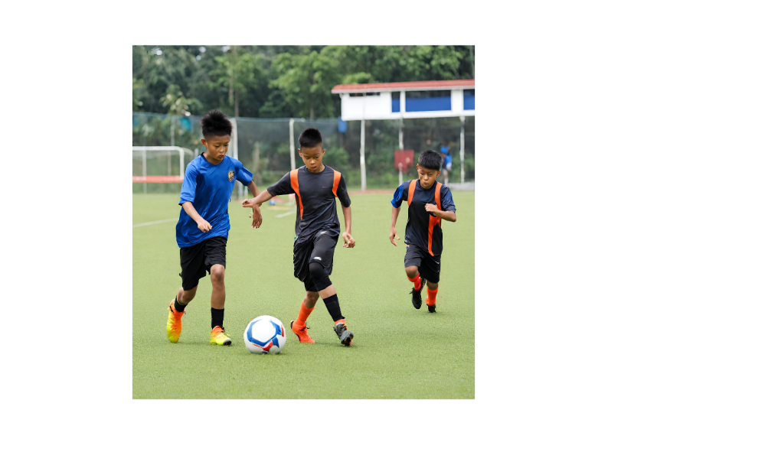

Figure 2: Football Activities

## 1.3 Problem Statement

Mr Rajib, the Junior Football Academy Malaysia Centre owner think that the current business mode should be integrated with a football academy management system to provide efficiency and reliable service and feature to stakeholders for expanding business. Based on the system request, the business process face significant challenges which cause low efficient on business operation. According to the current business process, the manual record system they are being used may concern some challenges when the increasing of data volume related to the operation activities. Since the data is key in manually by receptionist, there are data obsolete and data redundancy in the system. This may cause the data difficult to analysed and reflected the actual business operation status. Besides that, all customer’s billing is generated by receptionist including identifying activities type and price as well as calculating the total amount should be pay. This procedure is inefficiency for the billing process and may lead to billing and payment system inconsistency.

## 1.4 Aim

The aim of this assignment is to improve the effectiveness of the Junior Football Academy Malaysia Centre through the implementation of an information system. This system will manage appointments, bookings, schedules, billing, and payments resulting in enhanced customer service and overall business success.

1.5 Objectives

The objectives of the football training management system encompass several key areas: firstly, the development of an appointment management system aimed at streamlining appointment handling through automated confirmation and real-time availability checks. Secondly, the creation of a user-friendly booking management module integrating online booking and notification systems for customer updates. Thirdly, the establishment of a centralized scheduling system for coaches, offering them access, adjustment, and notification capabilities. Fourthly, the integration of an accurate and transparent automated billing system with flexible charging options. Fifthly, the implementation of a secure payment system with multiple options and encryption for financial security. Sixthly, the incorporation of personalized training plans based on scientific principles and tools for professional consultation and progress tracking for coaches. Seventhly, the development of a comprehensive news and events management system with features for updates, calendars, and announcements. Lastly, the integration of a feedback module for insights from players, parents, and coaches to enhance inquiries and feedback management.

# 2.0 Planning and Requirement Analysis

## 2.1 Gantt Chart

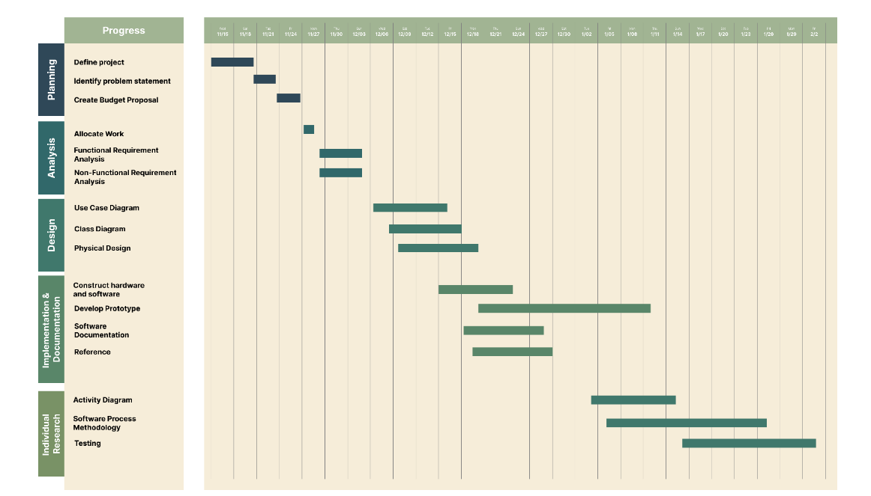

Figure 3: Gantt Chart

 The project begins by planning, where we establish our objectives identify the challenges we need to address and develop a plan to ensure we stay on track financially. Next we delve into analysis determining who will be responsible, for what tasks establishing timelines and delving into the details of our requirements in terms of both functionality and practicality. Moving on to design creativity comes into play as we sketch out how all the components will seamlessly work together. We create diagrams to help us visualize the project and thoroughly plan out its aspects. Once this is settled its time, for action. We construct the hardware and software components build prototypes and meticulously document everything for reference. Simultaneously research is a focus as we explore approaches and develop comprehensive testing strategies through diagram mapping activities. This systematic approach. Encompassing planning, analysis, design implementation documentation research. Provides us with a roadmap that ensures our project comes to life successfully while achieving our objectives.

## 2.2 Workload Matrix

|  |  |  |
| --- | --- | --- |
| Name | Responsibility | Signature |
| CHOK JUNG SHING | 1. Planning and Requirement Analysis (Functional Requirement and Non-Functional Requirement)  2. Physical Design | *Max* |
| LEW WAI HOW | 1. Logical Design 1 | *HOW* |
| LEONG SENG KHUAN | 1. Planning and Requirement Analysis (Workload Matrix and Budget Proposal)  2. Implementation (Software)  3. Reference | *SK* |
| TEH ZHONG CHENG | 1. Prototype  2. Conclusion | Cheng |
| TONG JIA CHUEN | 1. Introduction  2. Implementation (Hardware) | TONG |

## 2.3 Budget Proposal

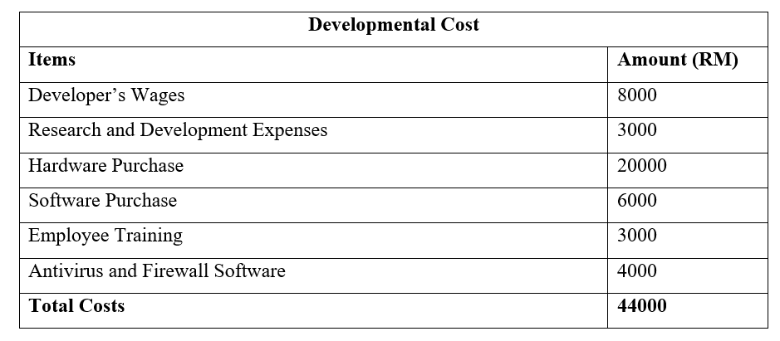

Table 1: Developmental Cost

Developmental costs represent a one-time occurrence in the system development phase, totalling RM44,000. These expenses cover developer wages, Research and Development (R&D) costs, hardware purchase, software tools acquired, employee training, and the installation of antivirus and firewall software. The R&D phase conducted during the initial development ensures the feasibility of the new system and analyses drawbacks in the existing system to prevent their recurrence in the new system. The hardware purchase, essential for system implementation, includes servers, storage, and other necessary devices. Additionally, software purchased from system developers is necessary to the system's functionality. To reduce potential risk during making payment, it's imperative to install antivirus and firewall tools. Once the system testing done, the company’s employees would require for training to familiarize themselves with the new system.

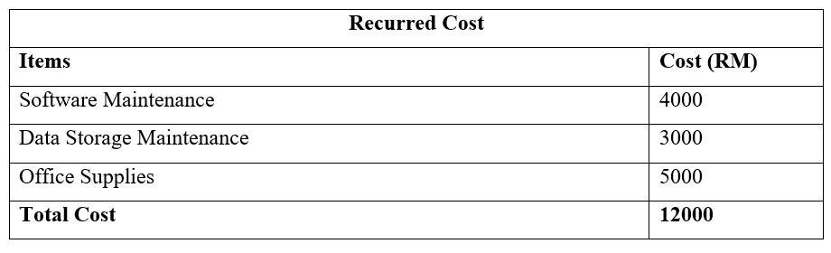

Table 2: Recurred Cost

Recurred costs are those incurred in daily operations and directly associated with system maintenance. Regular maintenance is conducted monthly to ensure the software remains updated with the latest versions and addresses any existing bugs. Additionally, the database administrator oversees the system storage to guarantee sufficient capacity for seamless operations. When storage nears capacity, the company is advised to expand it, whether through additional hard disk drives or cloud storage options. Office Supplies encompass various essential items crucial for administrative tasks and operational upkeep. For instance, they are essential for generating reports on customer payments, scheduling, and tracking training progress.

## 2.4 Functional Requirements

A functional requirement usually a specific service that the system must offer with the functionality. They show how the system should operate when the user input commands in specific situations. Essentially, functional requirements define what features and services that the system has to provide to the user when they are using. While user requirements may also give general idea of what the system should provide. Having functional system requirements will generate a clear picture of what the system should provide and capable of doing.

|  |  |
| --- | --- |
| **Functional Requirement** | **Description** |
| Manage Appointment | * The system should allow the customer to input information of the date and time of the training appointments, and essential information. * The system should send notifications to both trainers and customer for their appointment confirmation. * The system should provide real-time schedule for trainers and coaches to check on the appointments. * The system should allow receptionist to modify appointment information such as date, time and coaches, in order to maintain the business operation. |
| Manage Booking | * Customer should be able to select the venue and datetime, in order to make their bookings & training sessions through online web application. * Customers can also view their booking history through billing system. * An email or message will be sent to the customer once the booking is successful. * The system should allow receptionist to coordinate booking information such as venue, date and time. |
| Manage Trainer and Coach Schedule | * The system should allow receptionist to input coaches and trainer schedule, in order to generate available timetable for appointment. * The system should prevent overlapping training sessions and appointments among other trainers or coaches. * Up-to-date schedules will be presented in the web application for the trainers and coaches. |
| Manage Billing | * The system will have automatic functions of calculating the bills based on the activities that has been selected by the customers. * The system should update bill status in real time once customer pay for the bill. * The system allow receptionist to process payment by scanning the customer’s billing QR code. * The system should provide various payment methods such as cash, debit or credit card, GrabPay and TnG QR Pay. * The system should record and track down all payments, stating the customer's payment is paid or pending. * Payment confirmation receipts will be generated and printed to the customer once their payment has been successful. |
| Generate Report | * The system will generate daily, weekly, and monthly report of the organization’s sales. With all the information will be included in the sales report such as the appointment, types of activities, schedules, and etc. * Player progress report for trainers & coaches to view, allowing them to track down their progress and any improvements needed. |
| Manage News and Events | * The system should allow all users follow events related to the academy centre, for example, football competition. * The receptionist should have the authorization for adding, editing and deleting the news and events, in order to provide latest information. |
| Professional Consultation | * The players should be able to make a request for professional consultations with trainers/coaches for further advice and guidance in their training. * The consultation process should allow two-way conversation. |
| Manage Training Plan | * The system should allow trainers to create a personalized training plans for specific players. * The system should allow trainers to rate the player’s performance between the range of 1 star to 5 stars. |
| Manage Feedback and Inquiries | * The system should contain a feedback system where customers can give their feedback and opinions on trainers/activities. * The customers should be allowed to make inquiries by entering name, contact, parents’ name, email and question to receptionist for required information. * The receptionist should aid and reply to the customer’s inquiries. |

## 2.4 Non-Functional Requirements

A non-functional requirement on the other hand, set the rules of how the system should work. This includes the development process, following certain flow, timing, and etc. It basically applies to the entire system rather than just a feature. These requirements are very important as if one of them did not apply, the whole system might not work as it should.

|  |  |
| --- | --- |
| **Non-Functional Requirements** | **Description** |
| Security | * Each role has a different access control to ensure that certain authorizes personnel can access to the system’s information. * Minimal privilege access to reduce the risk of malicious access to the system. * Deploy secure hashing algorithm to hash user’s password. * Deploy encryption method in their database to protect customer’s information and business data. * User activities on scheduling, billing and payment management is being tracked to identify any security breaches. |
| Usability | * Having a user-friendly user interface for all users, including trainers, customers, coaches, receptionists. * Fast response time for actions in the system while using the web application. * Provide coaches a customization options to personalize training plans and flexibility to customize billing processes if needed. * The system should offer a user-friendly interface with clear menu and navigation to make appointments, payments and gaining access to training resources. |
| Reliability | * Having scheduled maintenance 24hours on standby and system’s availability is at 99.9% of the time. * An automated backup system will be implemented to ensures that in any case of system failures or data loss, it can be restored. * When errors occur within the system, error messages need to be promptly sent to receptionist. |
| Performance | * The system should be able to store large amount of data of customer’s information, appointments, training schedules, and etc. * The system should provide smooth user interactions without delaying in performances. * The system optimized data retrieval operations to assure fast scheduling and billing information. |
| Scalability | * The system should be able to handle a considerable number of customers, trainers, and coaches effectively. * The system should be able to scale continuously to handle more coaches, staff and customer as the academy grows. |

# 3.0 Logical Design Part 1

## 3.1 Use Case Diagram

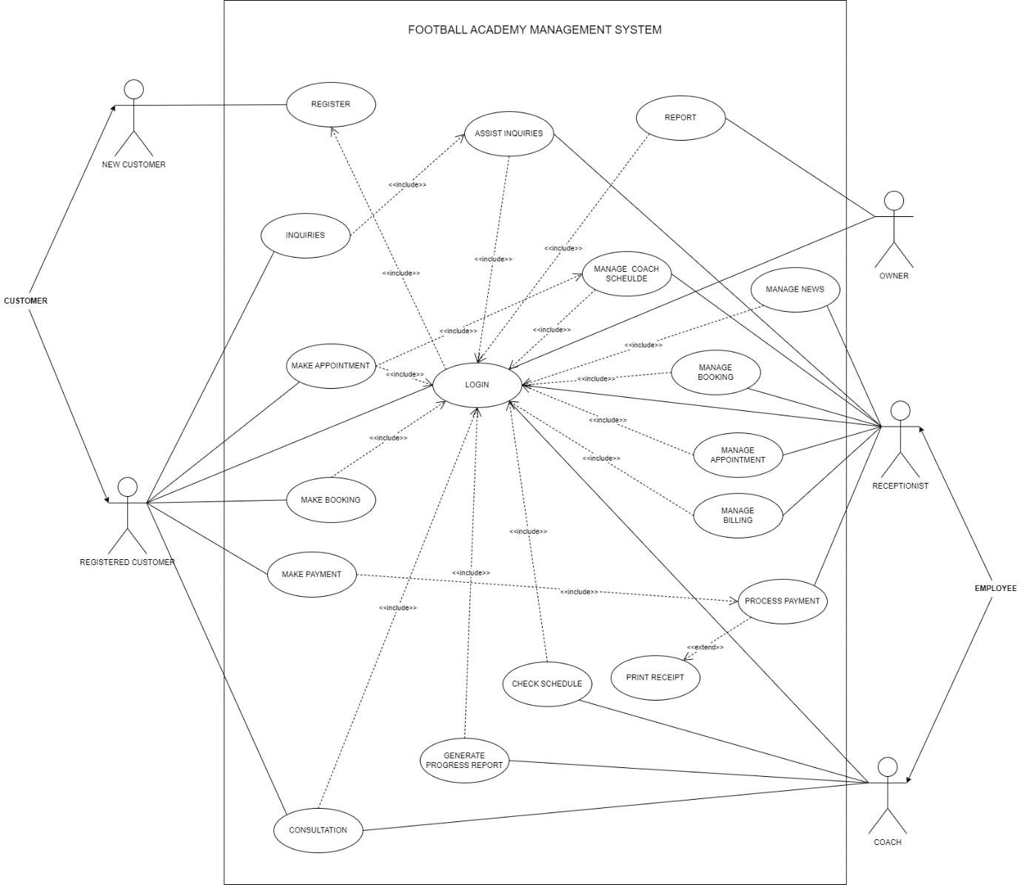

Figure 4: Use Case Diagram

The new football academy management system includes most of the business’s activities. There are two entities involve in the system, which are customers and employees.

**1. Customers**

Customers can be categorized as either new customers or registered customers. New customers are required to register for their account in order to log in to the system. Upon logging into the system, customers can schedule appointments for training, make booking for session, deal payment for billing, engage in consultations with coaches, and seek more information through inquiries.

The appointment and booking arranged by schedule management system, in addition, appointment is also generated based on coach schedule. Payment for billing can be made after receptionist process it. If a customer encounters any issues or wishes to share their opinions regarding the system and academy’s service, they are encouraged to submit inquiries to the receptionist. Afterward, they can view the inquiries assistant report based on their inquiries. In addition, it enables customers to consult coaches for football skill improvements.

**2. Employee**

Receptionists and trainers are both generalized as employees, although they have distinct roles within the system. They are granted access to specific functions following user authentication. The receptionist possesses the authority to manage all activities and monitor system operations. For instance, the receptionist can manage customer billing, modify coach schedule, coordinate appointment and booking, and generate assistance reports for customer inquiries. Since the system consist of news features, it is necessary for receptionist to update news information into the system. Furthermore, receptionist can scan customer’s billing QR code to process payment after they finish session. The payment detail and amount are based on the billing information. Once customers deal the payment, a receipt may be generated for documentation.

On the other hand, coaches have more direct interaction with players. After concluding a training session, coaches are required to update the player's progress report. This report reflects the player’s performance during training and helps plan the next steps in the training process. Additionally, coaches can engage in conversations with players, providing feedback on areas for improvement and sending progress reports to them. Besides that, coaches would need to check their schedule on specific days for preparation.

**3. Owner**

In addition, the owner holds a higher level of authorization within the system. The owner is empowered to send report generation requests to the system for various types of reports. This includes customer record report, appointment and booking report, inquiries assistance report and financial report.

## 3.2 Class Diagram

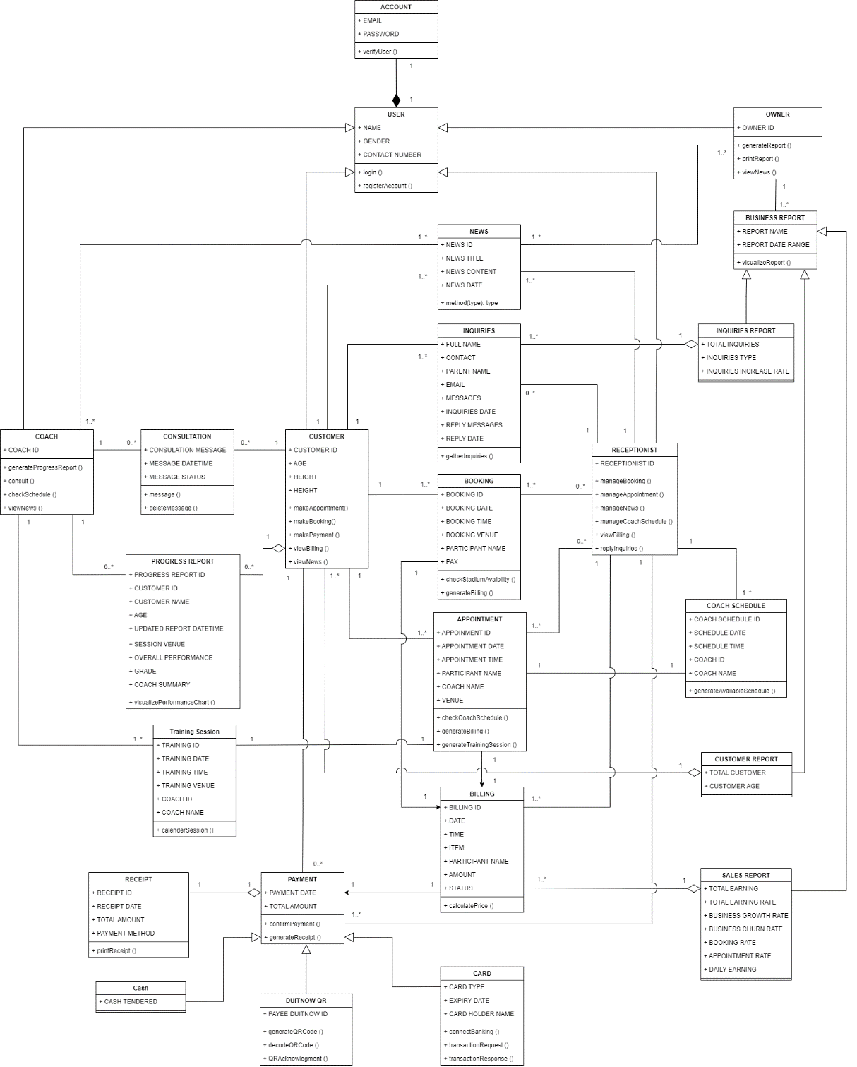

Figure 5: Class Diagram

The User class represents the end user who interacts with the system to perform tasks. The Owner, Receptionist, Coach, and Customer classes can be generalized as users, sharing common attributes like name, gender, contact number, and email. Each user has their own account, encompassing attributes such as email and password. This account, crucial for system access, is entirely created by the user. Consequently, deleting the user class affects the associated account. All roles in the system can follow the news and events to know the activities in the academy centre.

The Owner class possesses the capability to generate and print one or many business reports, including Sales Report, Customer Report, and Inquiries Report. These report types inherit attributes from the Business Report, such as report name and report date range. Each report aggregates data from classes like Inquiries, Customer, and Billing, crafting a comprehensive view reflecting the business situation.

Customers or players are associated with one or many activities such as booking, appointment, inquiries, payment, and consultation. Customers employ the methods makeBooking () and makeAppointment() to connect with the Booking and Appointment classes. Post-appointment creation, the Appointment class may associate with the Training Session class, generating a new training session. Coaches can communicate with the Training Session class to retrieve and view one or many customers' training sessions, facilitating training preparation. To facilitate billing, customers have three payment options: cash, card payments, and QR payments. These payment methods inherit attributes from the Payment class, such as payment date and total amount paid. Furthermore, receipt is a part of payment which is use bidirectional aggregation connect to payment class. Each payment has one receipt to prove the payment status.

Moreover, coaches possess the ability to write and update one or many customers' progress reports, with each progress report forming an integral part of the customer. Coach class also relate to zero or many consulation class for conversing with customers or players through message () method.

The Receptionist class serves as a central point of communication, interacting with core classes such as Inquiries, Booking, Appointments, Billing, Coach Schedule, News and Events. Receptionists manage news and events, bookings, appointments, and coach schedules. They can view customers' bills, process payments, and reply to inquiries. If no inquiries are made, the receptionist may associate with zero inquiries.

# 4.0 Physical Design

## 4.1 Customer

### 4.1.1 Home Page and Login Page

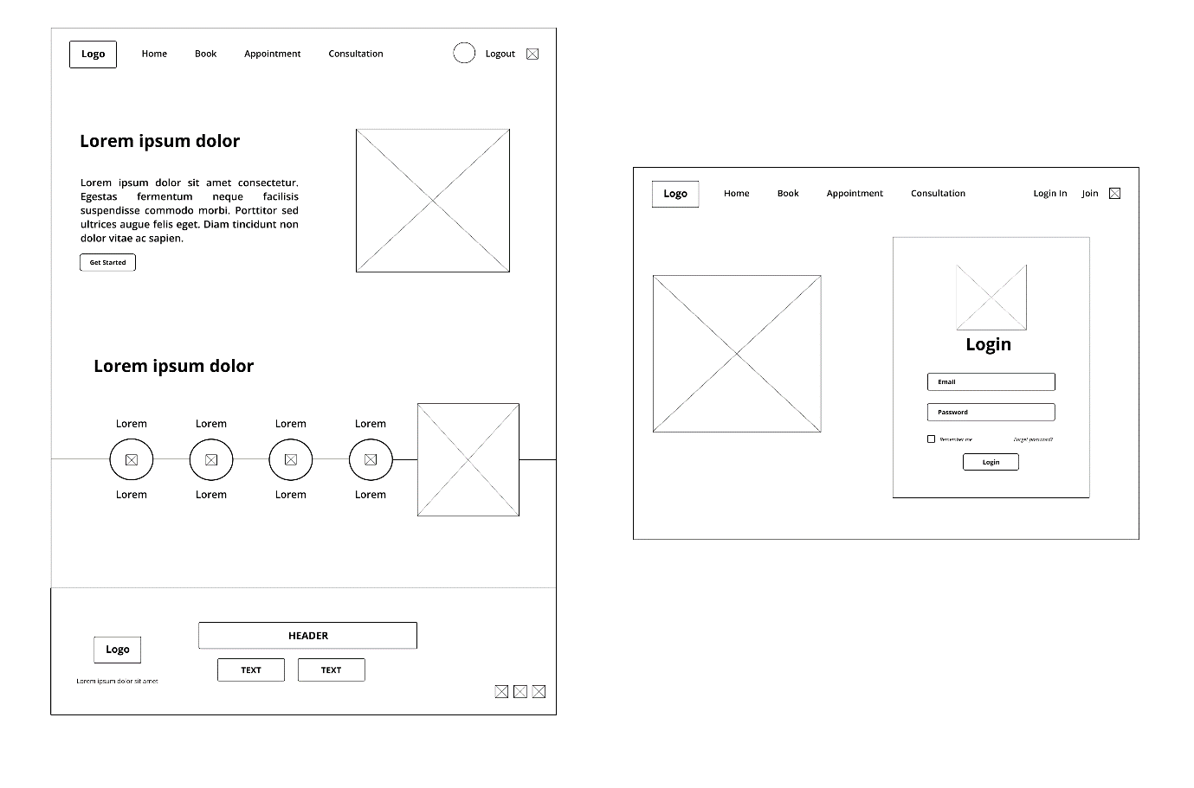

Figure 6: Home Page and Login Page

This home page showcases Junior Football Academy Malaysia Centre’s new website. A simple logical design with a navigational panel on top of the website. All contents included below that directs to different sections. Customer’s login page that requires them to input their email & password to proceed for further action on the website.

### 4.1.2 Booking Page

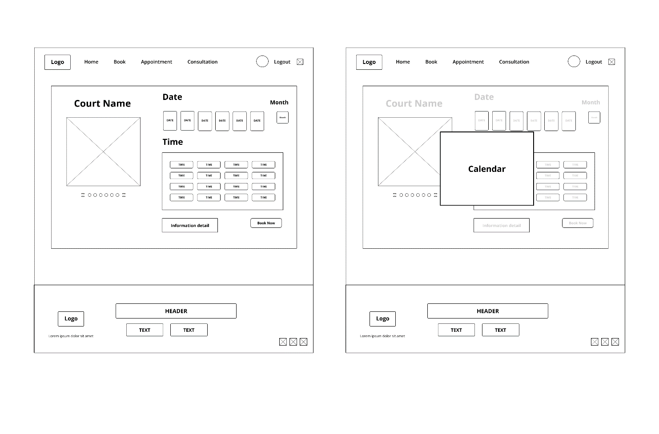

Figure 7: Make Booking Page

This page allows customer to make bookings with their court, date, and time. Which will have images included in the prototype of the court’s view. The function that allows customer to quickly select the date they prefer on the booking page.

4.1.3 Appointment Page and Consultation Page

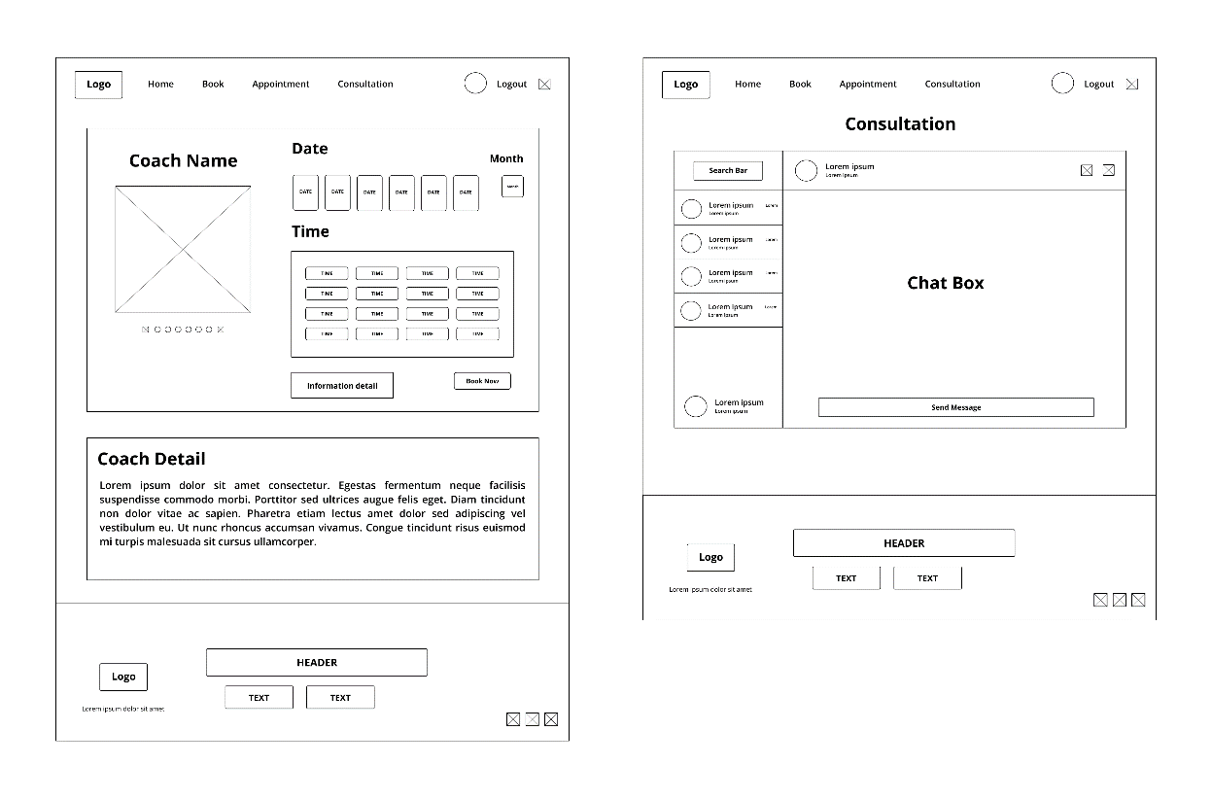

Figure 8: Make Appointment Page and Consultation Page

Appointment Page for customer to make an appointment for the coach they wanted. Consultation Page which connects both customer and coach in a chat box for any communications.

### 4.1.7 Inquiries Page

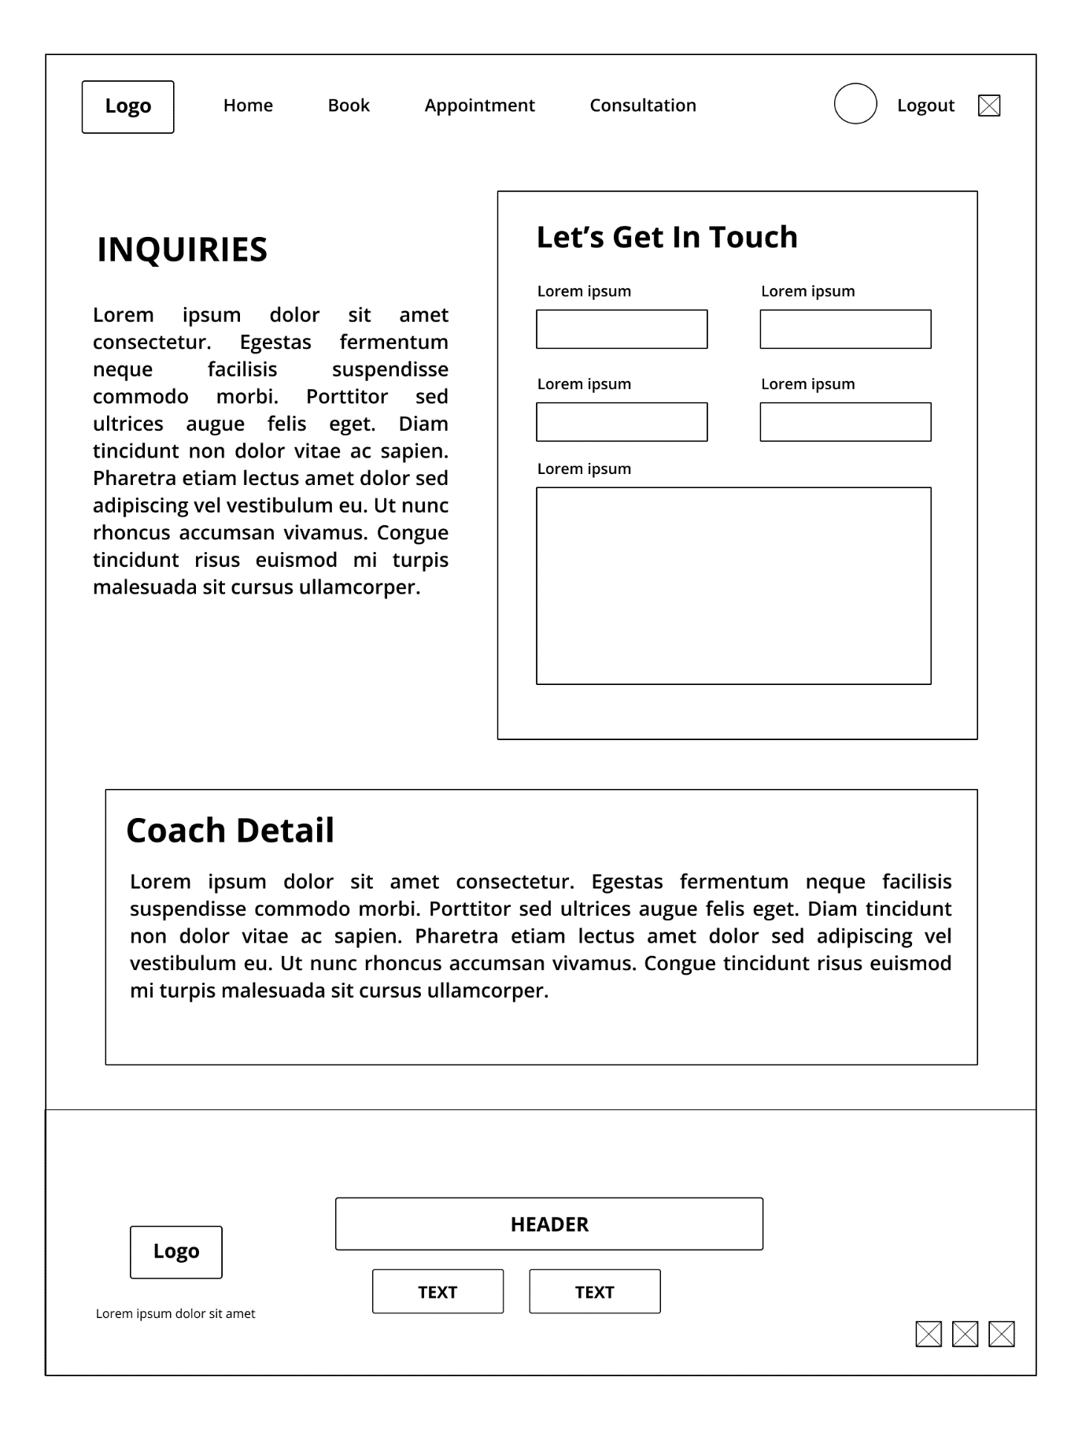

Figure 9: Inquiries Page

This page will record down information about the customers and allows owner or receptionist to get in touch with them. Other than that, we will be including the customer support function as wells.

## 4.2 Receptionist

### 4.2.1 Inquiries Page

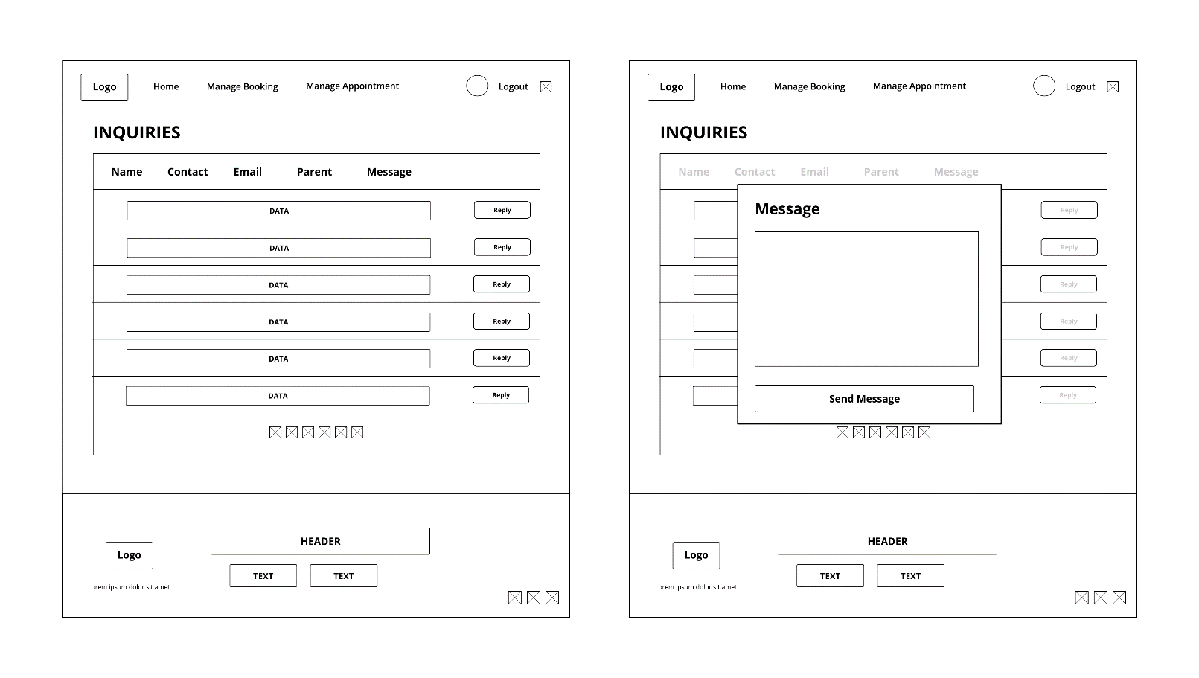

Figure 10: Manage Inquiries Page

Receptionist can view customer’s information and data through this page. Receptionist can also reply to their messages from the customer support they requested. The function with a pop out message box to reply customer’s message and support.

### 4.2.2 News and Event

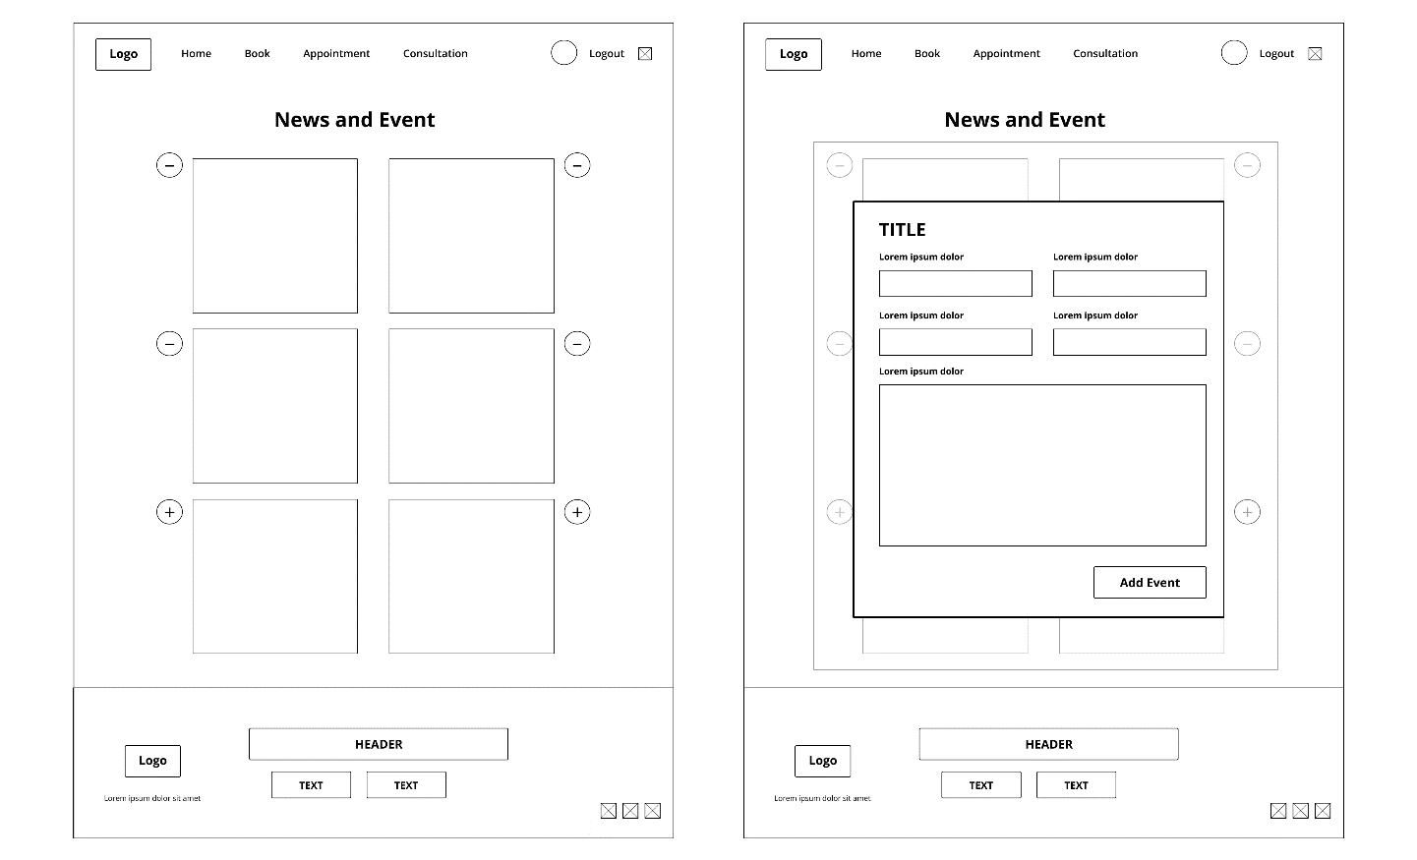

Figure 11: Manage News and Event Page

This page will include updated news and upcoming events about the Junior Academy Football Centre. Negative & Positive buttons for adding new news/events and to remove them also. Receptionist can modify the content of the news/events in this page. A pop out box which allows receptionist to input the information and details.

### 4.2.3 Manage Billing

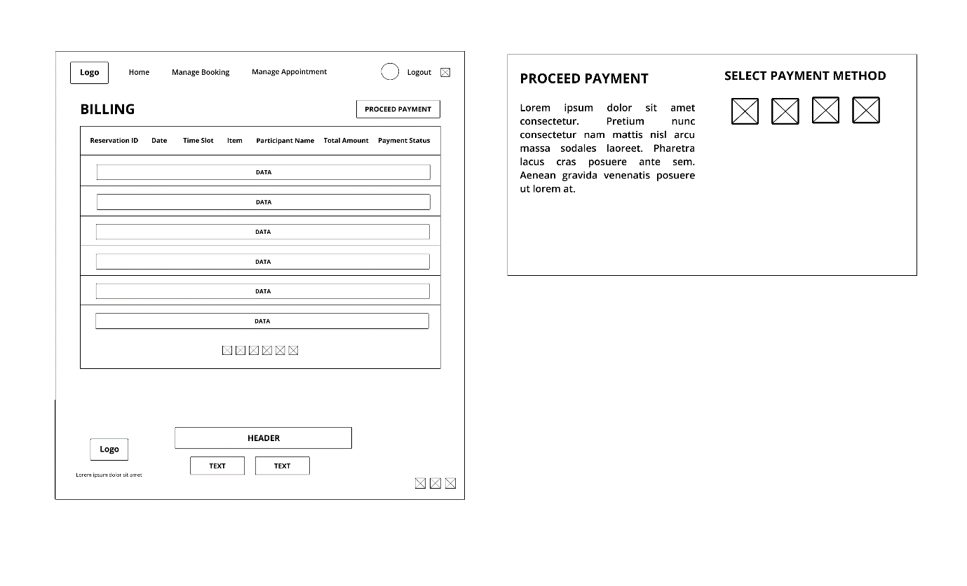

Figure 12: Manage Billing Page

Receptionist can refer customer’s billing through this page. Manage billing activity and transactions status. The proceed payment button will direct to a page that allows customer to select their preferred payment that will be done on the spot face to face.

### 4.2.4 Manage Booking and Appointment

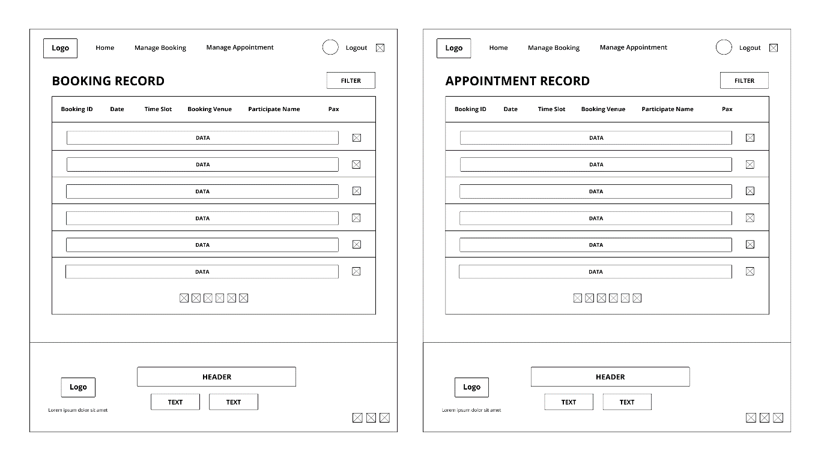

Figure 13: Manage Booking Page and Manage Appointment Page

Receptionist can view booking and appointment records through these 2 pages such as date, time, venues, and activities. Manage customer booking data and appointment data as well as modifying it.

### 4.2.5 Manage Coach Schedule

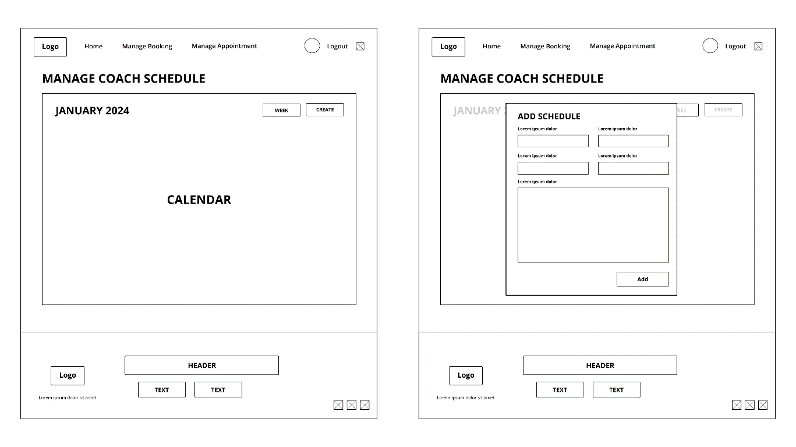

Figure 14: Manage Coach Schedule Page

Receptionist can access this page for managing coach schedule. Creating new schedule and sessions for the coaches. Updating the date and time based on the availability slot on the calendar of the coach schedule for Junior Academy Football Centre.

## 4.3 Coach

### 4.3.1 View Schedule

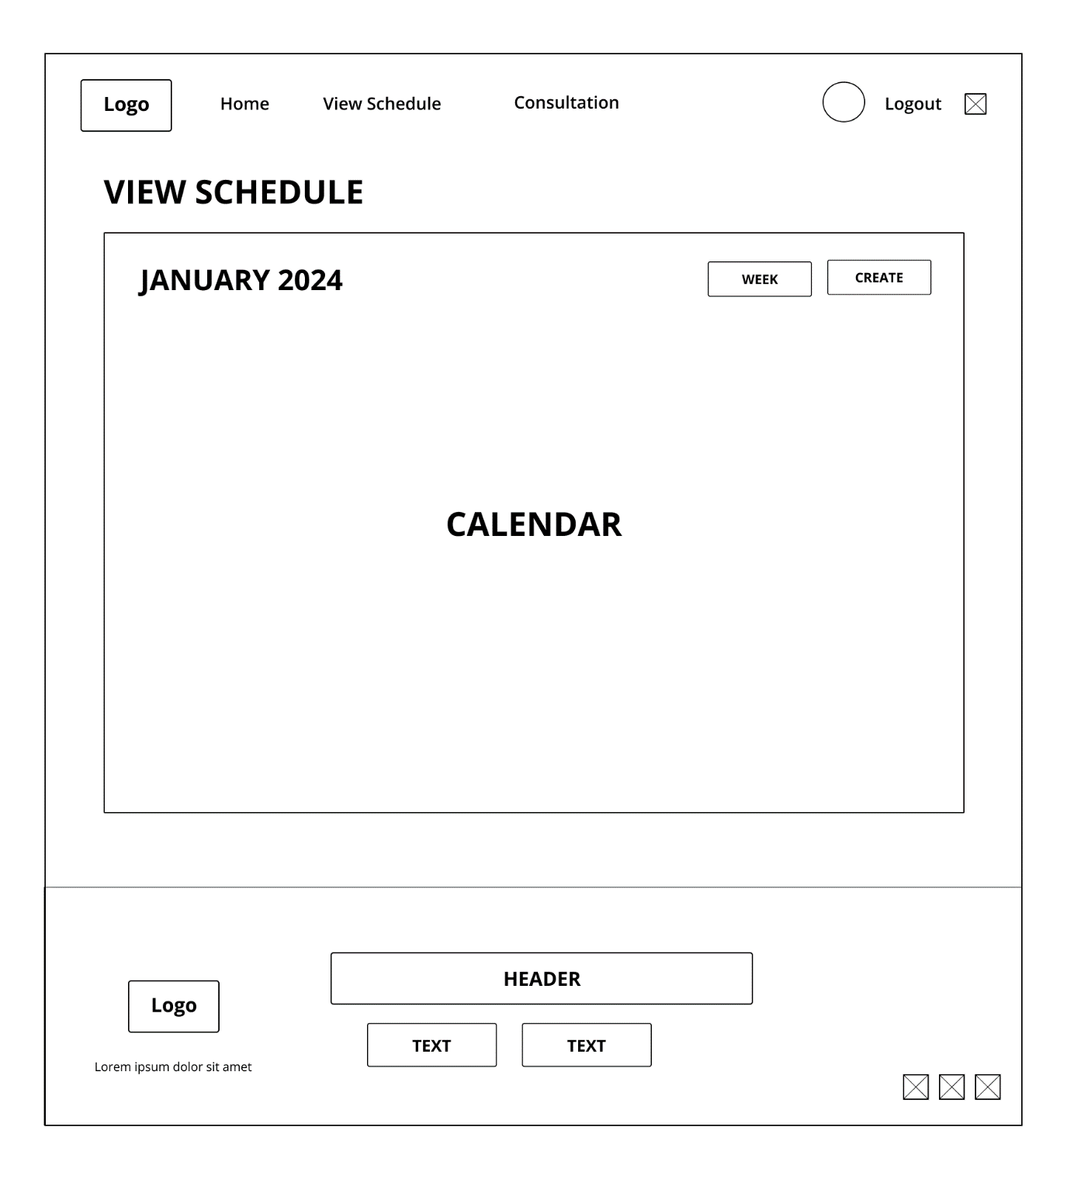

Figure 15: View Schedule Page

Each coach can view their own schedule through this page. All detailed information will be displayed for the coaches to know their coaching sessions with the calendar displayed as well.

### 4.3.2 Write Progress Report

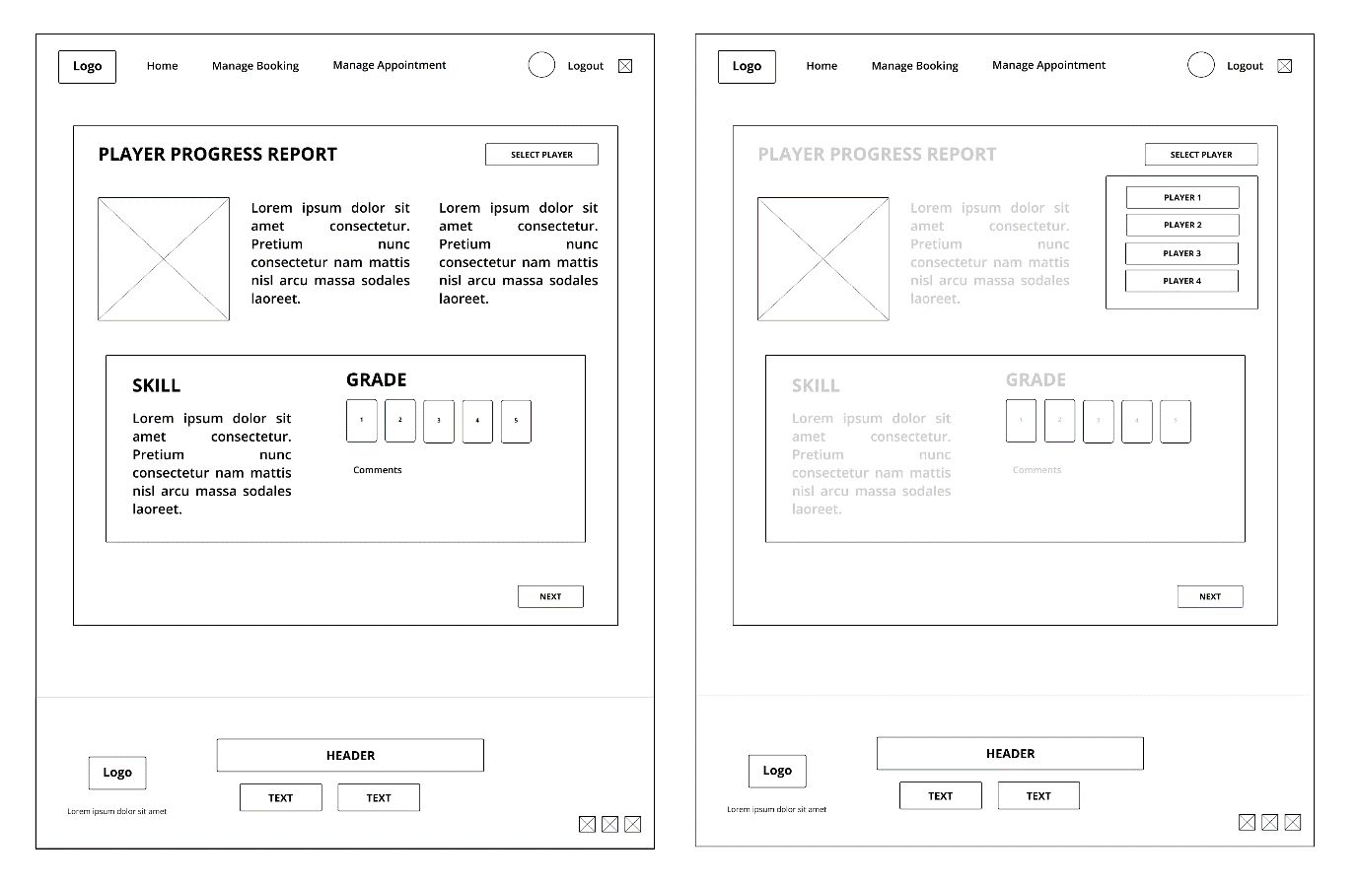

Figure 16: Write Progress Report Page

Coaches can write down each player’s progress report and view the player’s performance through this page meanwhile improving them. Record down the skillset they have learned on that day and grades given by their performance throughout the day training session.

## 4.4 Owner

### 4.4.1 Generate Business Report

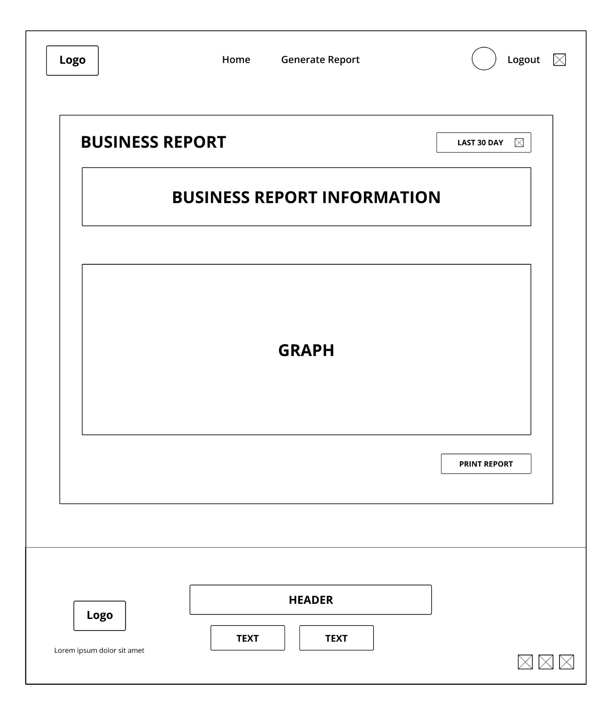

Figure 17: Generate Business Report Page

Owner can generate a business report for Junior’s Academy Football Centre on this page. Inserting the business information and the statistics graph for a record. Tracking down Junior’s Academy Football Centre’s growth and improvements. Other than that, owner can also print the record down for further reference later on.

# 5.0 Implementation

## 5.1 Hardware

The proposed information system can only be effective with a solid hardware structure, The hardware features are given below allow for efficient appointment scheduling, booking procedures, invoicing, payment processing, reporting, and other critical activities.

1.Server infrastructure:

* Using a Dell PowerEdge or HP ProLiant server equipped with twin Intel Xeon processors with 8 cores each, as well as Hyper-Threading for efficient multitasking, offers powerful processing capabilities. This is supported by a huge 64GB ECC DDR4 RAM, which can manage simultaneous user requests and database activities. Storage is managed using enterprise-grade SSDs set in RAID 10, which offers a mix between performance and redundancy, with read and write rates of 550 MB/s and 500 MB/s, respectively. For better efficiency and security, the server operates a Linux-based operating system, including Ubuntu Server or CentOS. With this implementation of modern hardware and a Linux-based operating system it creates an effective foundation for the information system.

2.Networking:

* Our team use Catalyst switches and an ISR series router that are examples of enterprise-grade Cisco networking equipment. The Catalyst switches and ISR series router contain Gigabit Ethernet ports, Layer 3 routing, and VLAN functionality.

3. Client Devices:

* With a primary focus on Chrome, our team members at the Junior Football Academy have taken extra effort to guarantee seamless compatibility with the most modern web browsers on user devices, including PCs, laptops, tablets, and mobile devices. The is suitable for devices with modern CPUs, ensuring optimal performance when acquiring entry to the data system. The Junior Football Academy Malaysia Center's information system also uses SSD storage and 4GB RAM to enhance speed and efficiency, allowing for a smooth fast user experience.

4.Backup system and Power backup:

* The Junior Football Academy Malaysia Centre has a two-pronged approach for creating a complete backup and power emergency plan. A backup server duplicates the primary server's specs and runs the same Linux-based operating system, providing a local protection for vital data. Meanwhile, a cloud-based backup service, such as AWS S3, is automatically connected, customizing storage capacity and transfer speeds to meet changing data volumes. As for the issue of power backup, enterprise-grade UPS systems, such as the APC Smart-UPS with a 5kVA capacity, enable a smooth shutdown during outages, reducing the risk of data damage. Also, a backup generator with a minimum capacity of 20kVA is specified to provide continuous system functioning during long power outages, strengthening the Academy's information system's robustness. 5.Power Backup:

5. POS (Point of sale) :

* The Junior Football Academy Malaysia Centre's Point of Sale (POS) equipment contains advanced Card Readers and Receipt Printers to help with financial operations. Card Readers, such as the model Verifone V400m are used in the Junior Football Academy Malaysia. Moreover, receipt Printers, such as the model Epson TM-T88V, are used for their high-speed capabilities, which allow rapid and effective printing of transaction receipts. With, this technological advancement being implemented in Junior Football Academy Malaysia it will ensure a safe and seamless POS experience for customer and the company.

## 5.2 Software

With the limitations of the current manual system, a solid software is an essential role for handling a football academy management system. With these software features given below helps more efficiently handling appointments, bookings, schedules, billing, payments, and contribute to the overall success of the academy.

**Chrome Operating System**

Our team uses Chromebook from ChromeOS to build a new football academy management system which is also simple to set up. What is good about using ChromeOS is that ChromeOS keeps different software inside Chromebook separately with Sandboxing. If one part gets attacked or infected, the rest still stay safe. Moreover, Chromebook helps to protect the user’s data, and it includes a built-in security chip to encrypt and protect user most sensitive data. Every time ChromeOS is used, it goes through Verified Boot to check-up in the background to prevent malware, phishing attack, etc. (Google, ChromeOS features - Google ChromeBooks, 2019)

**Payment Management**

Our team uses FPX software from PayNet to access digital banking. FPX offers a straightforward setup process for digital banking. It is reliable and your financial details are guaranteeing securely encrypted and never shared with an outsider. Moreover, FPX helps the Junior Football Academy Malaysia Centre owner to save up tons of money by not having any transaction fees. Payments are processed immediately from your internet banking account in real-time providing immediate notification via phone or email after the transaction is successful. ((M.), 2017)

**Booking Management**

Utilizing the MySQL database, our system empowers coaches with a seamless and efficient query mechanism to reserve training courts. This feature allows coaches to book available slots according to their training schedules. To maintain a well-organized and conflict-free training environment, our system prioritizes the prevention of overlapping sessions among different trainers. Administered exclusively by the admin, the system facilitates easy updates and management of schedules. A notification will have triggered after admin update the schedule, ensuring transparent communication by notifying all relevant parties, especially coaches, that specific time slots have been successfully booked by one of their peers. This meticulous approach guarantees the prevention of scheduling conflicts and enhances overall coordination within the football academy.

**Log and Backup System**

Since we are using ChromeOS that is built in the new system, Cloud Storage from Google Cloud aligns perfectly with the new system, as each software was developed by Google companies. Cloud Storage is a common choice that helps to manage service for storing any amount of data and retrieve it as often. It offers a feature called Object Lifecycle Management (OLM), which allows owners to easily optimize costs with object placement across the storage classes. (Google, Cloud Storage, 2008)

# 

# 6.0 Prototype

## 6.1 Customer

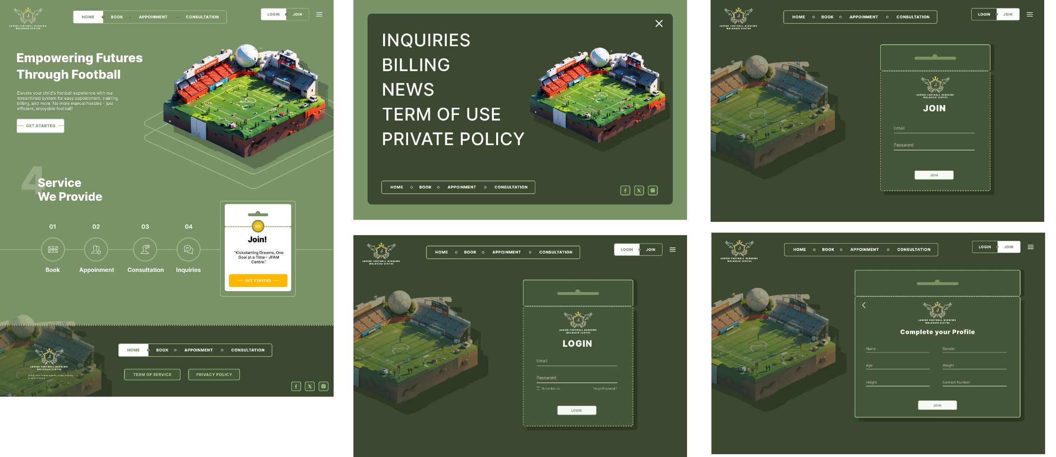

Figure 18: Customer Home Page, Navigation Page, Login Page, and Join Page

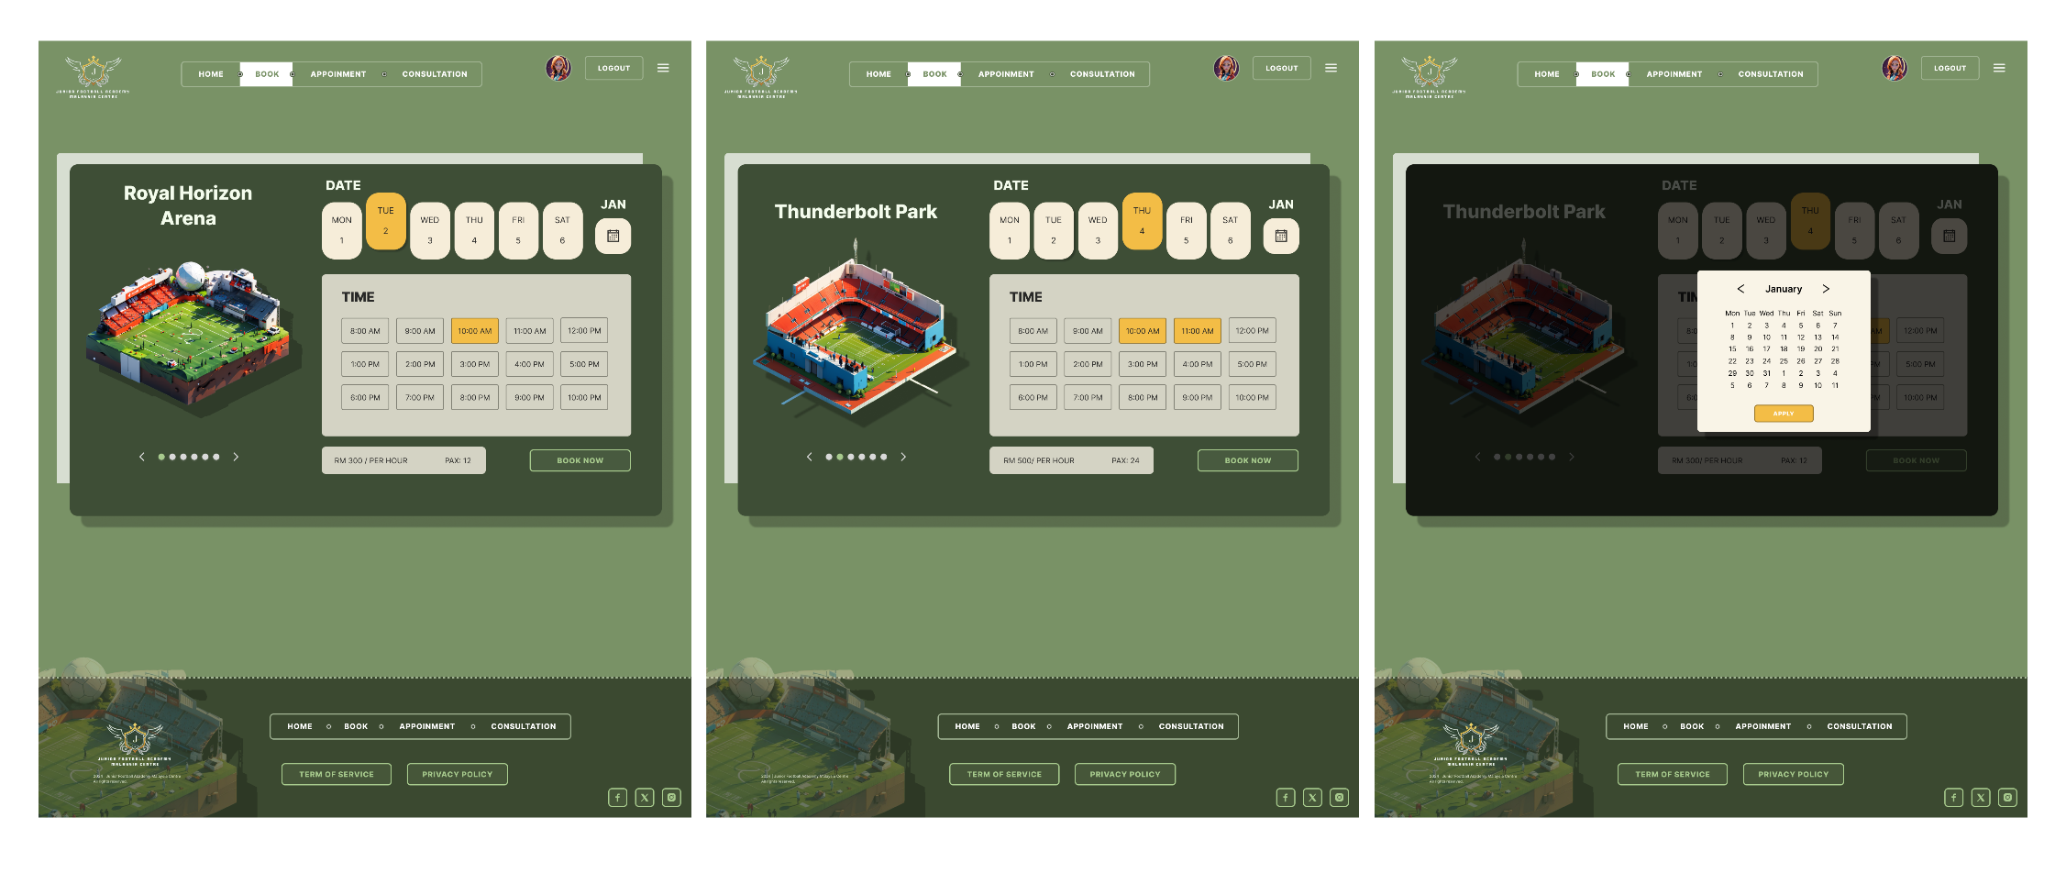

Figure 19: Make Booking Page

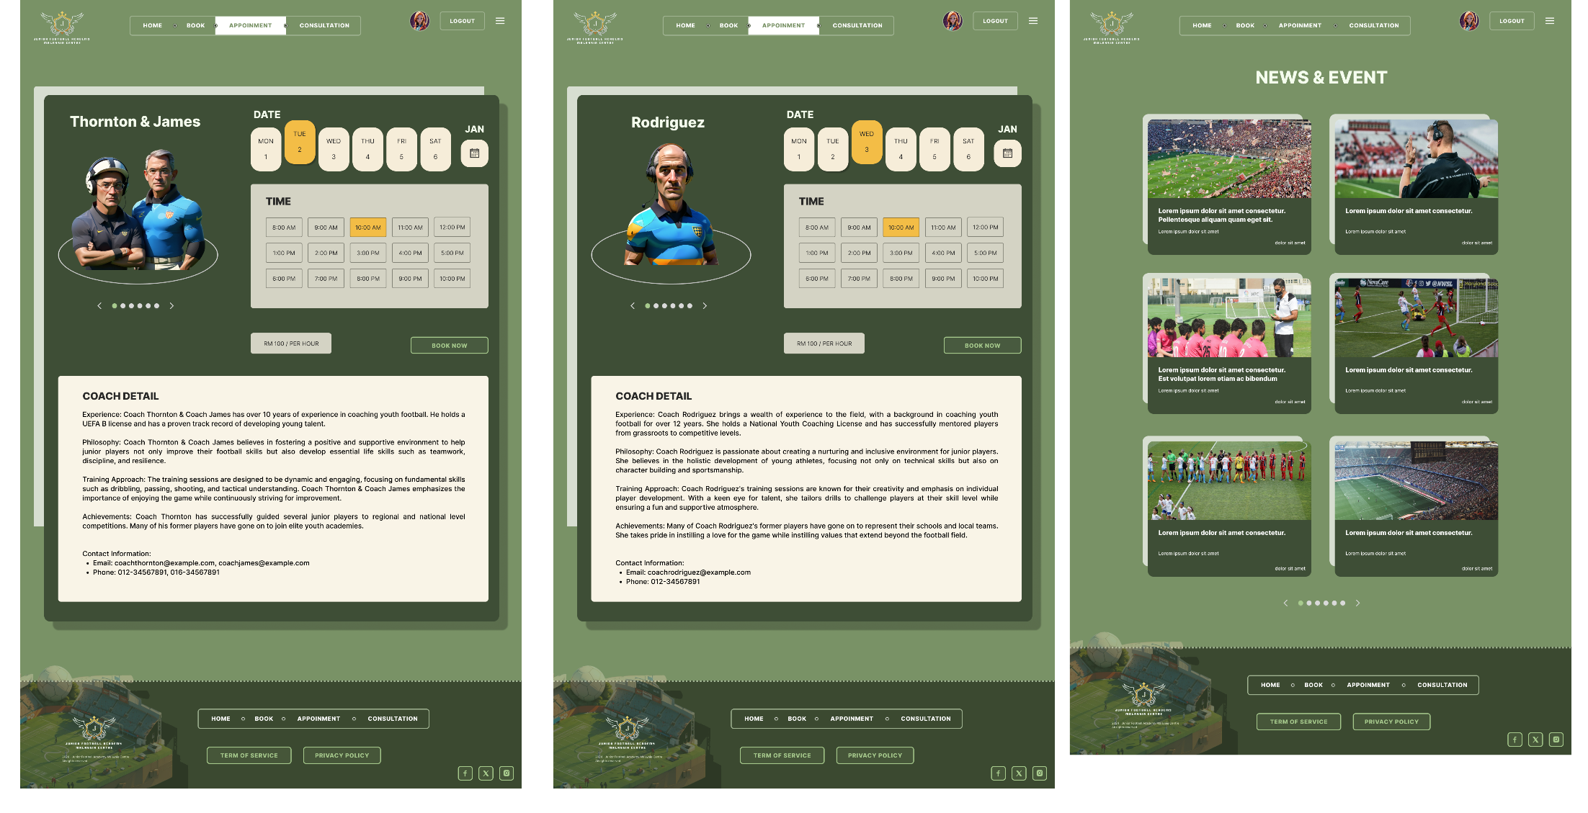

Figure 20: Make Appointment Page and News & Event Page

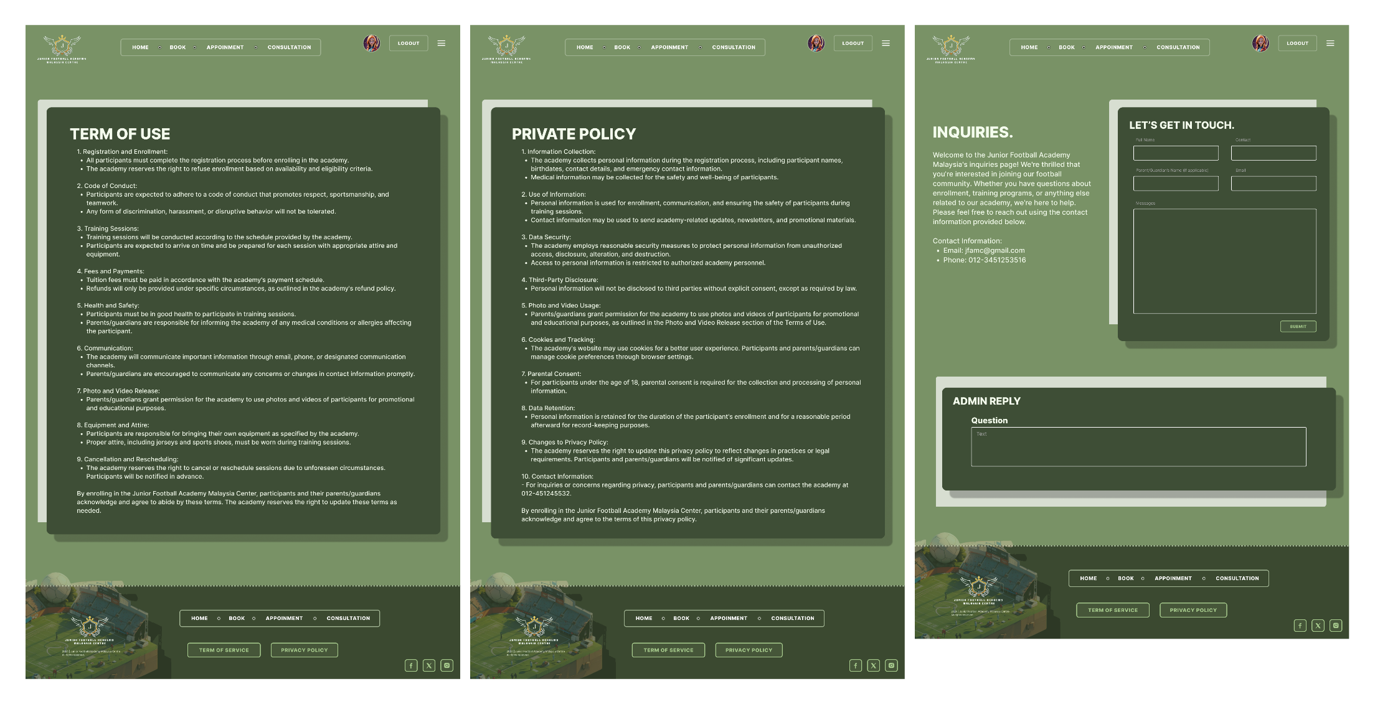

Figure 21: Term of Use Page, Private Policy Page, and Inquiries Page

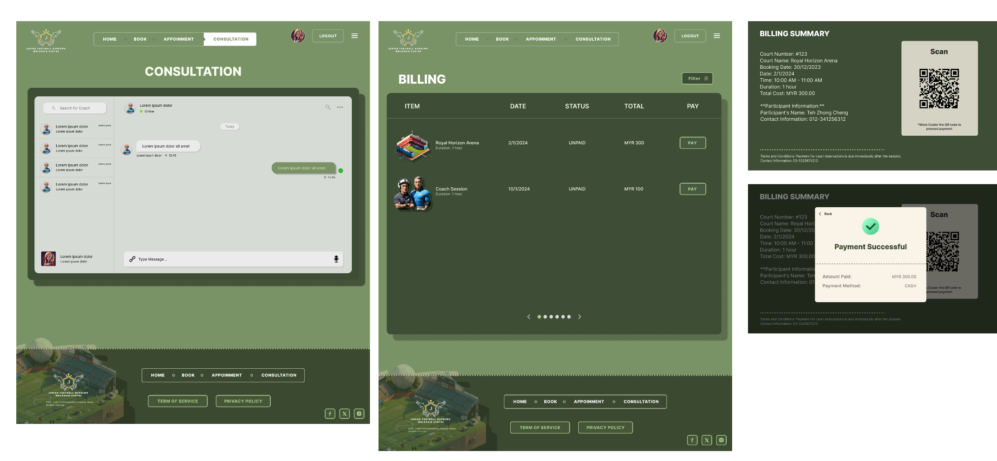

Figure 22: Consultation Page, and Billing Page

## 6.2 Receptionist

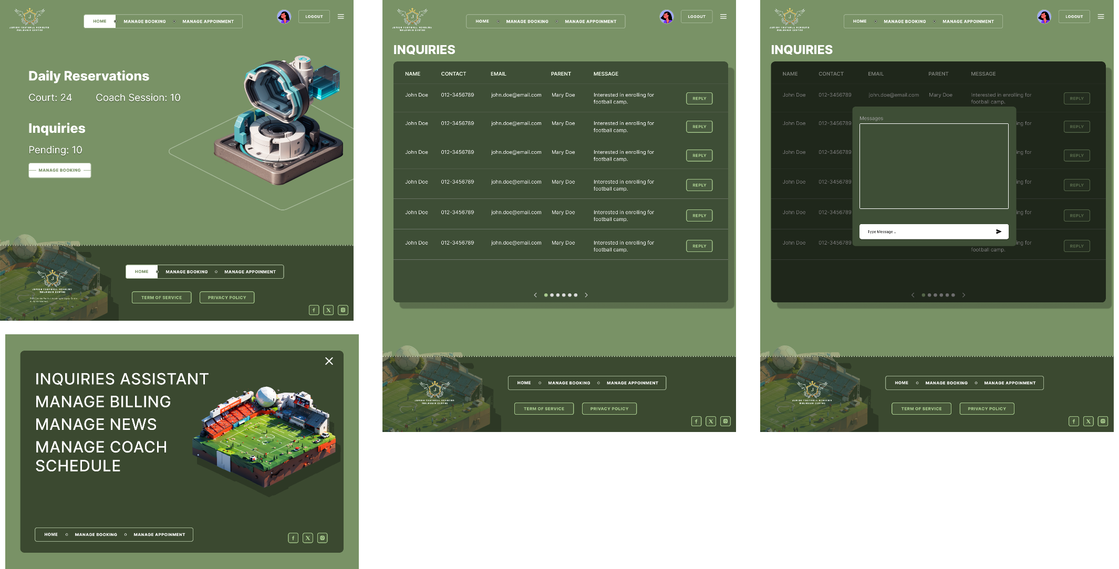

Figure 23: Receptionist Home Page, Navigation Page, and Manage Inquiries Page

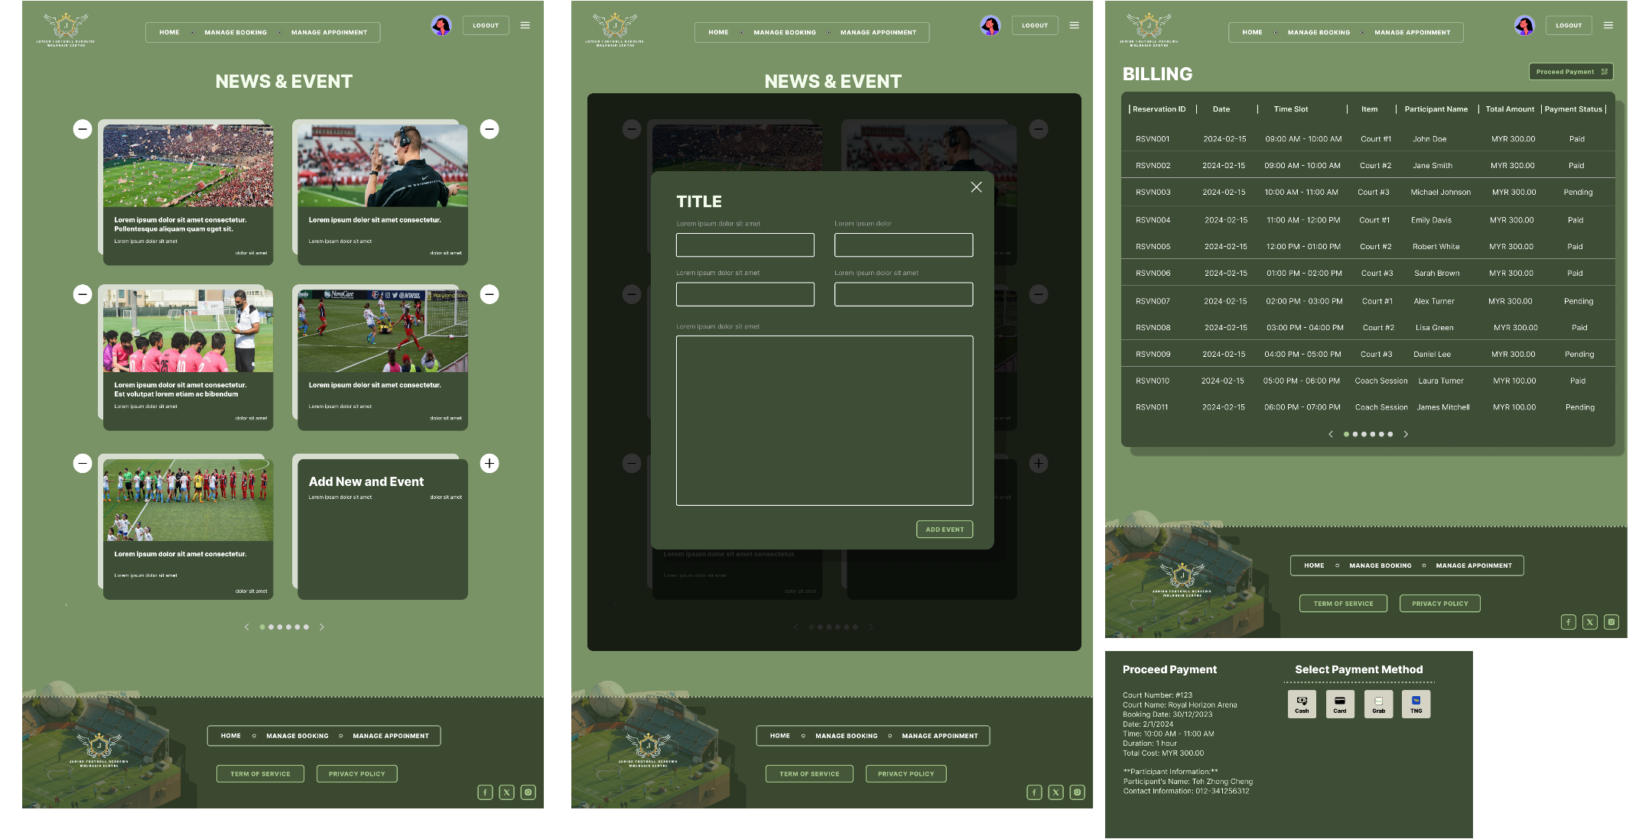

Figure 24: Manage News & Event Page, and Manage Billing Page

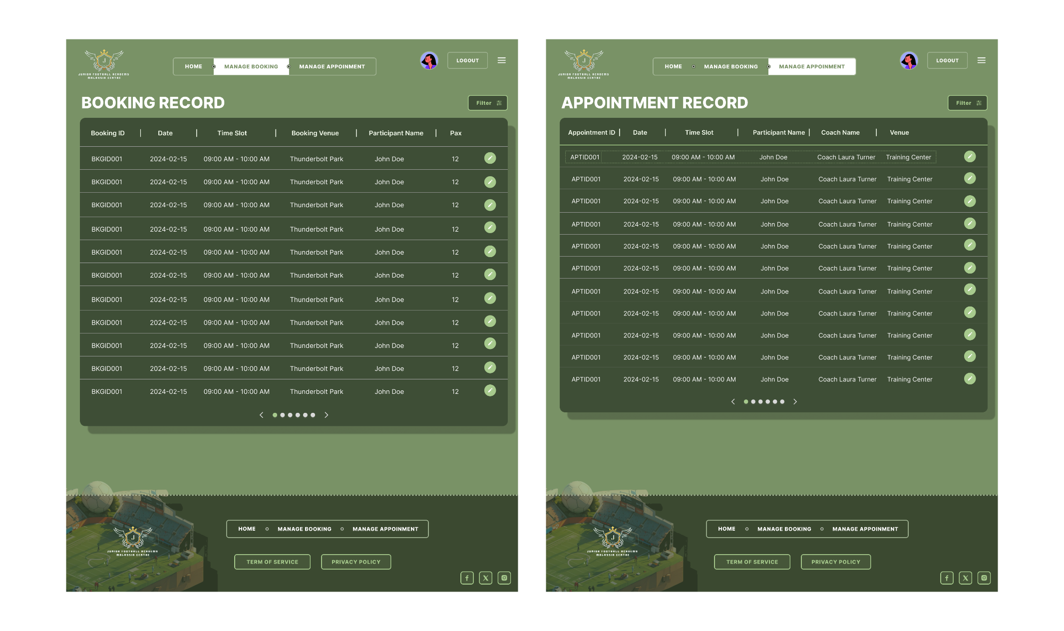

Figure 25: Manage Booking Page and Manage Appointment Page

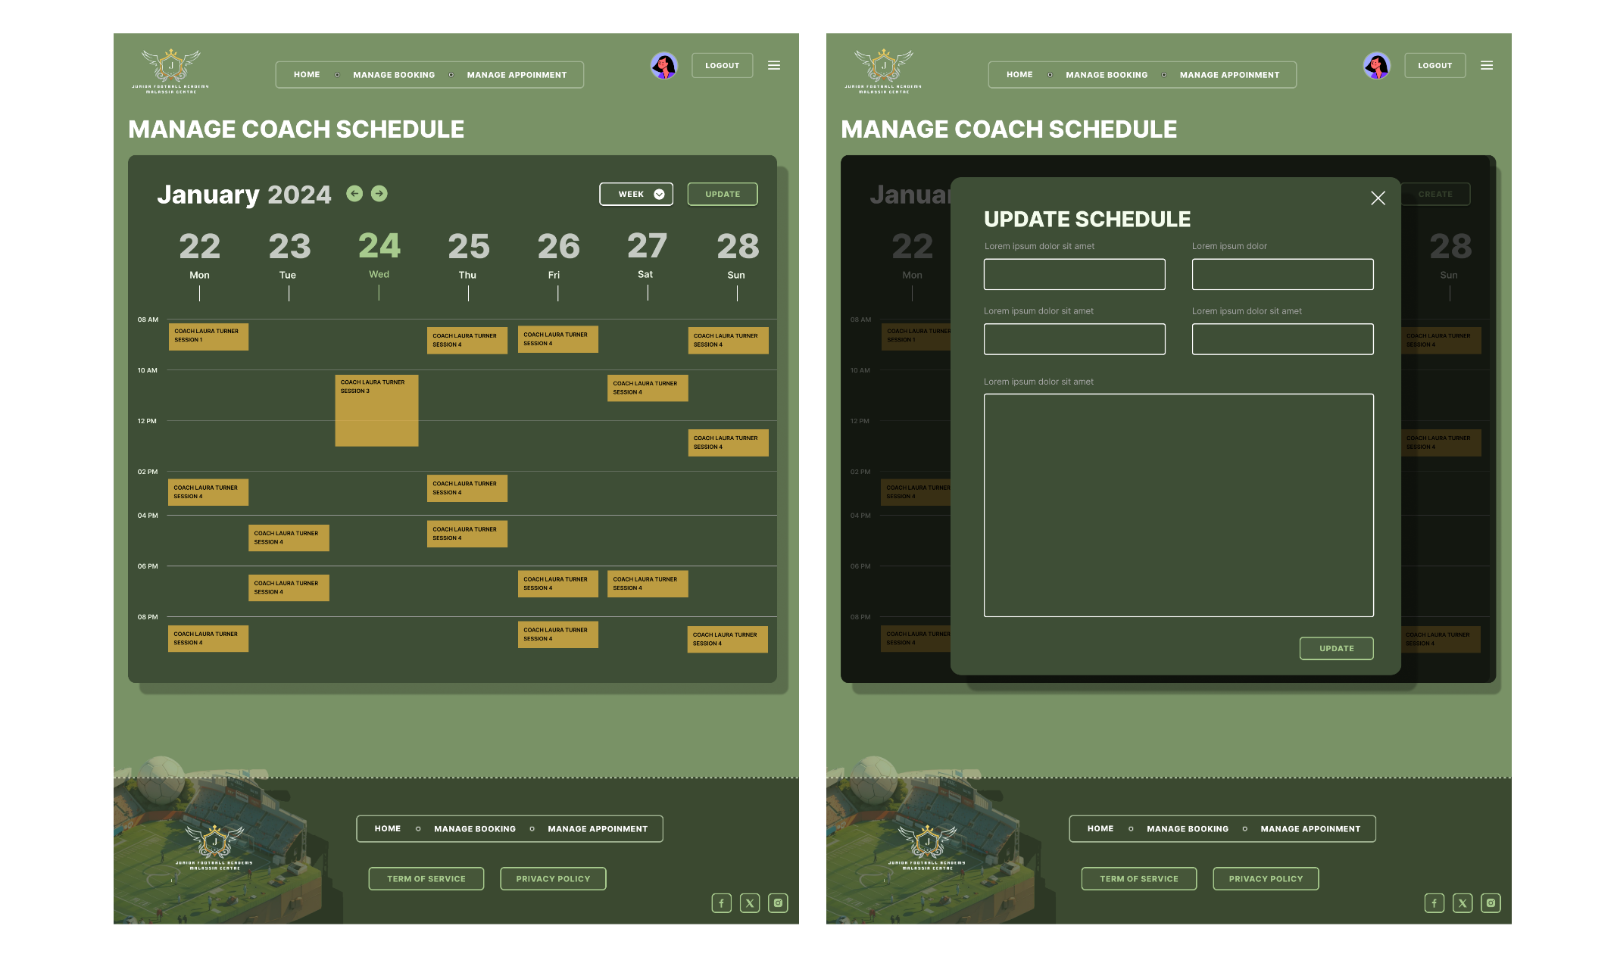

Figure 26: Manage Coach Schedule Page

## 6.3 Coach

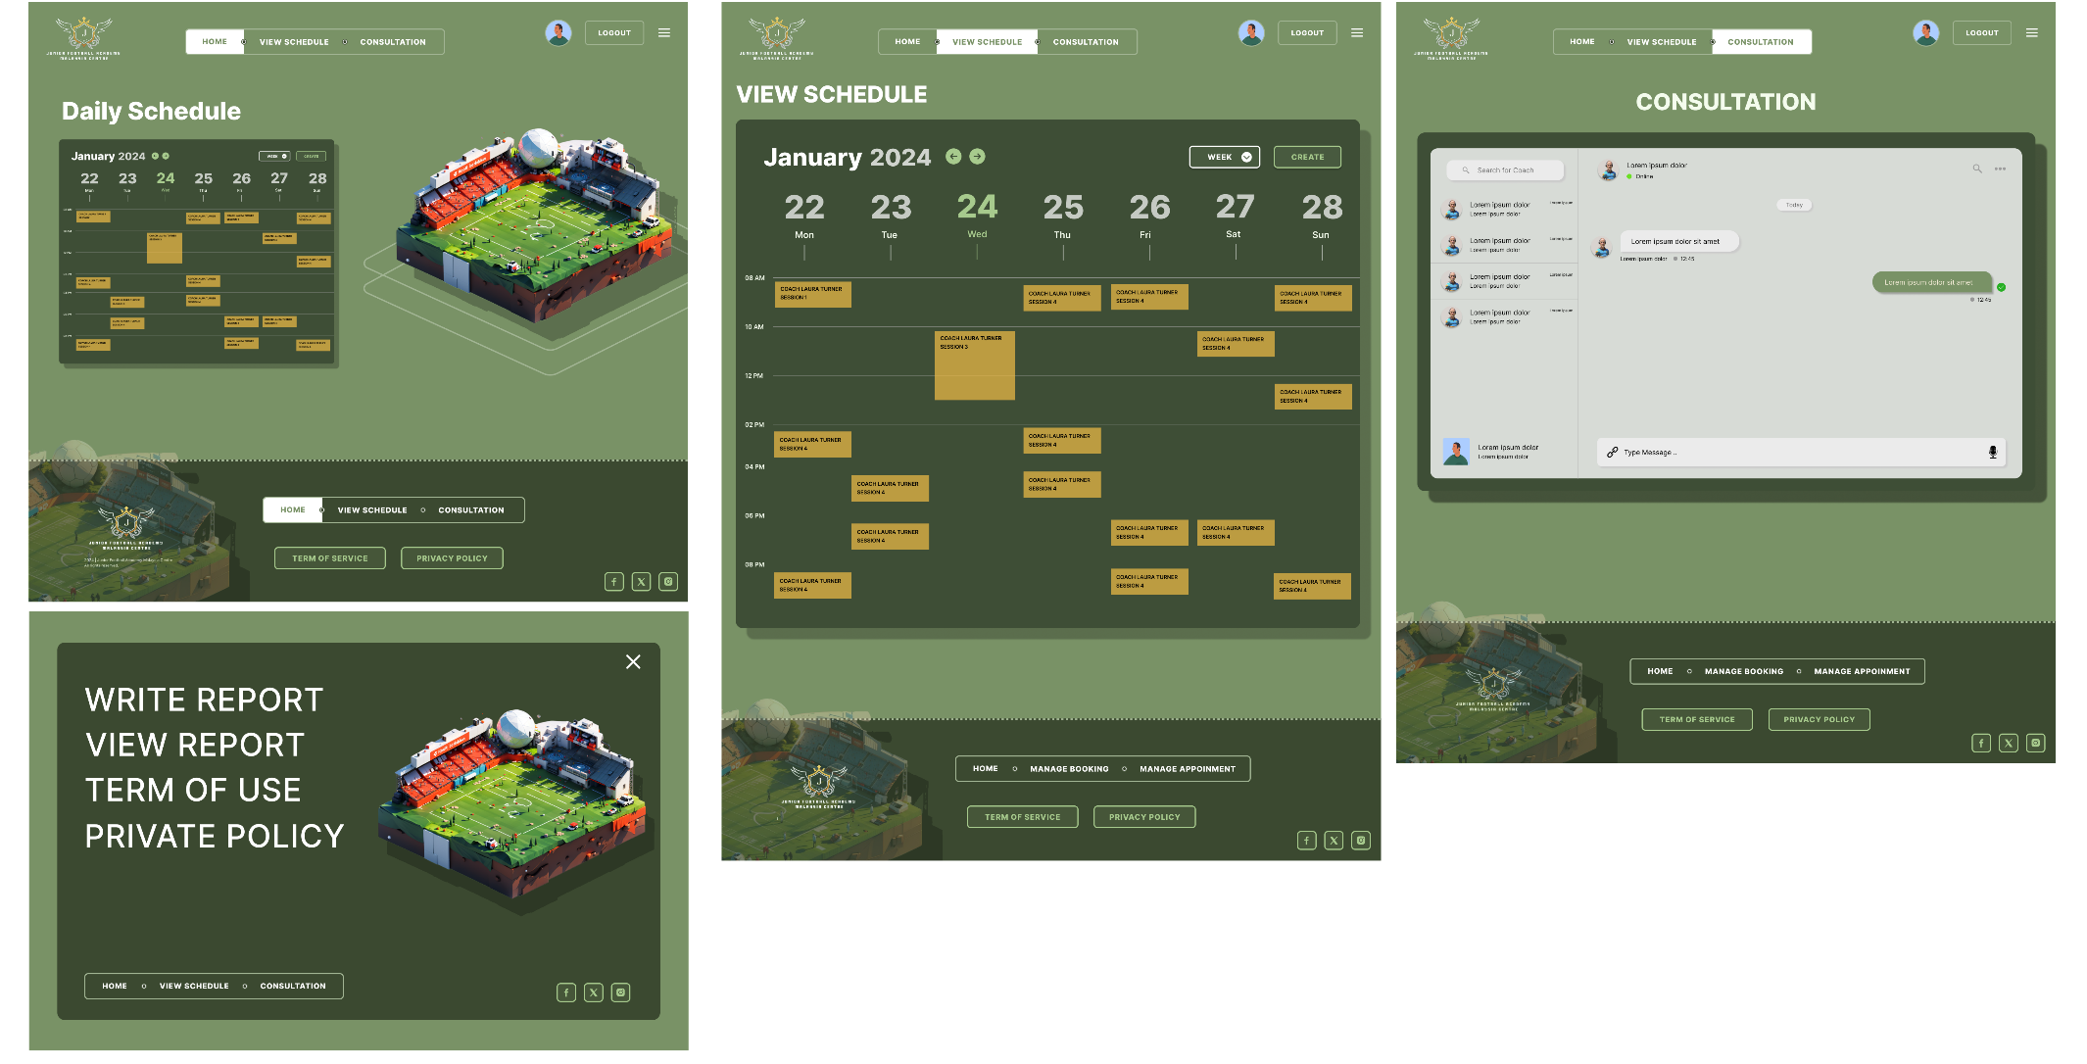

Figure 27: Coach Home Page, Navigation Page, View Schedule Page, and Consultation Page

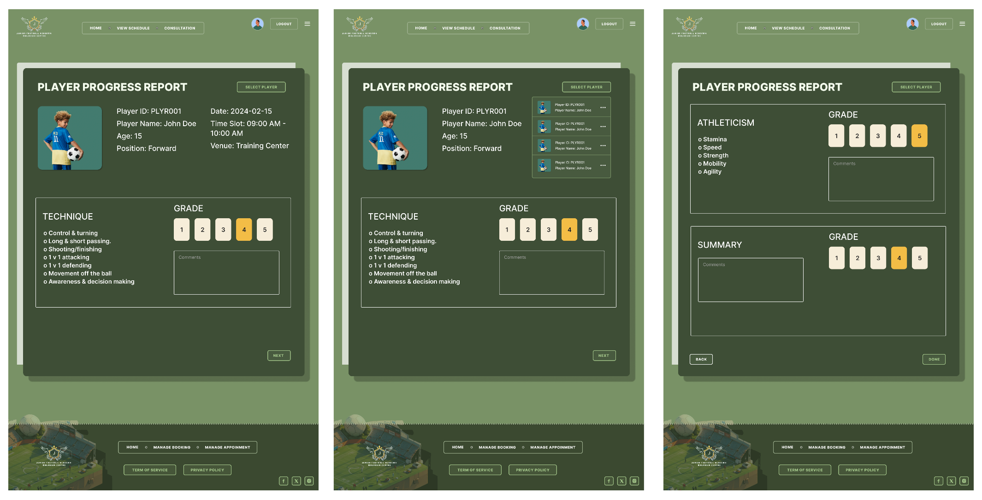

Figure 28: Write Progress Report Page

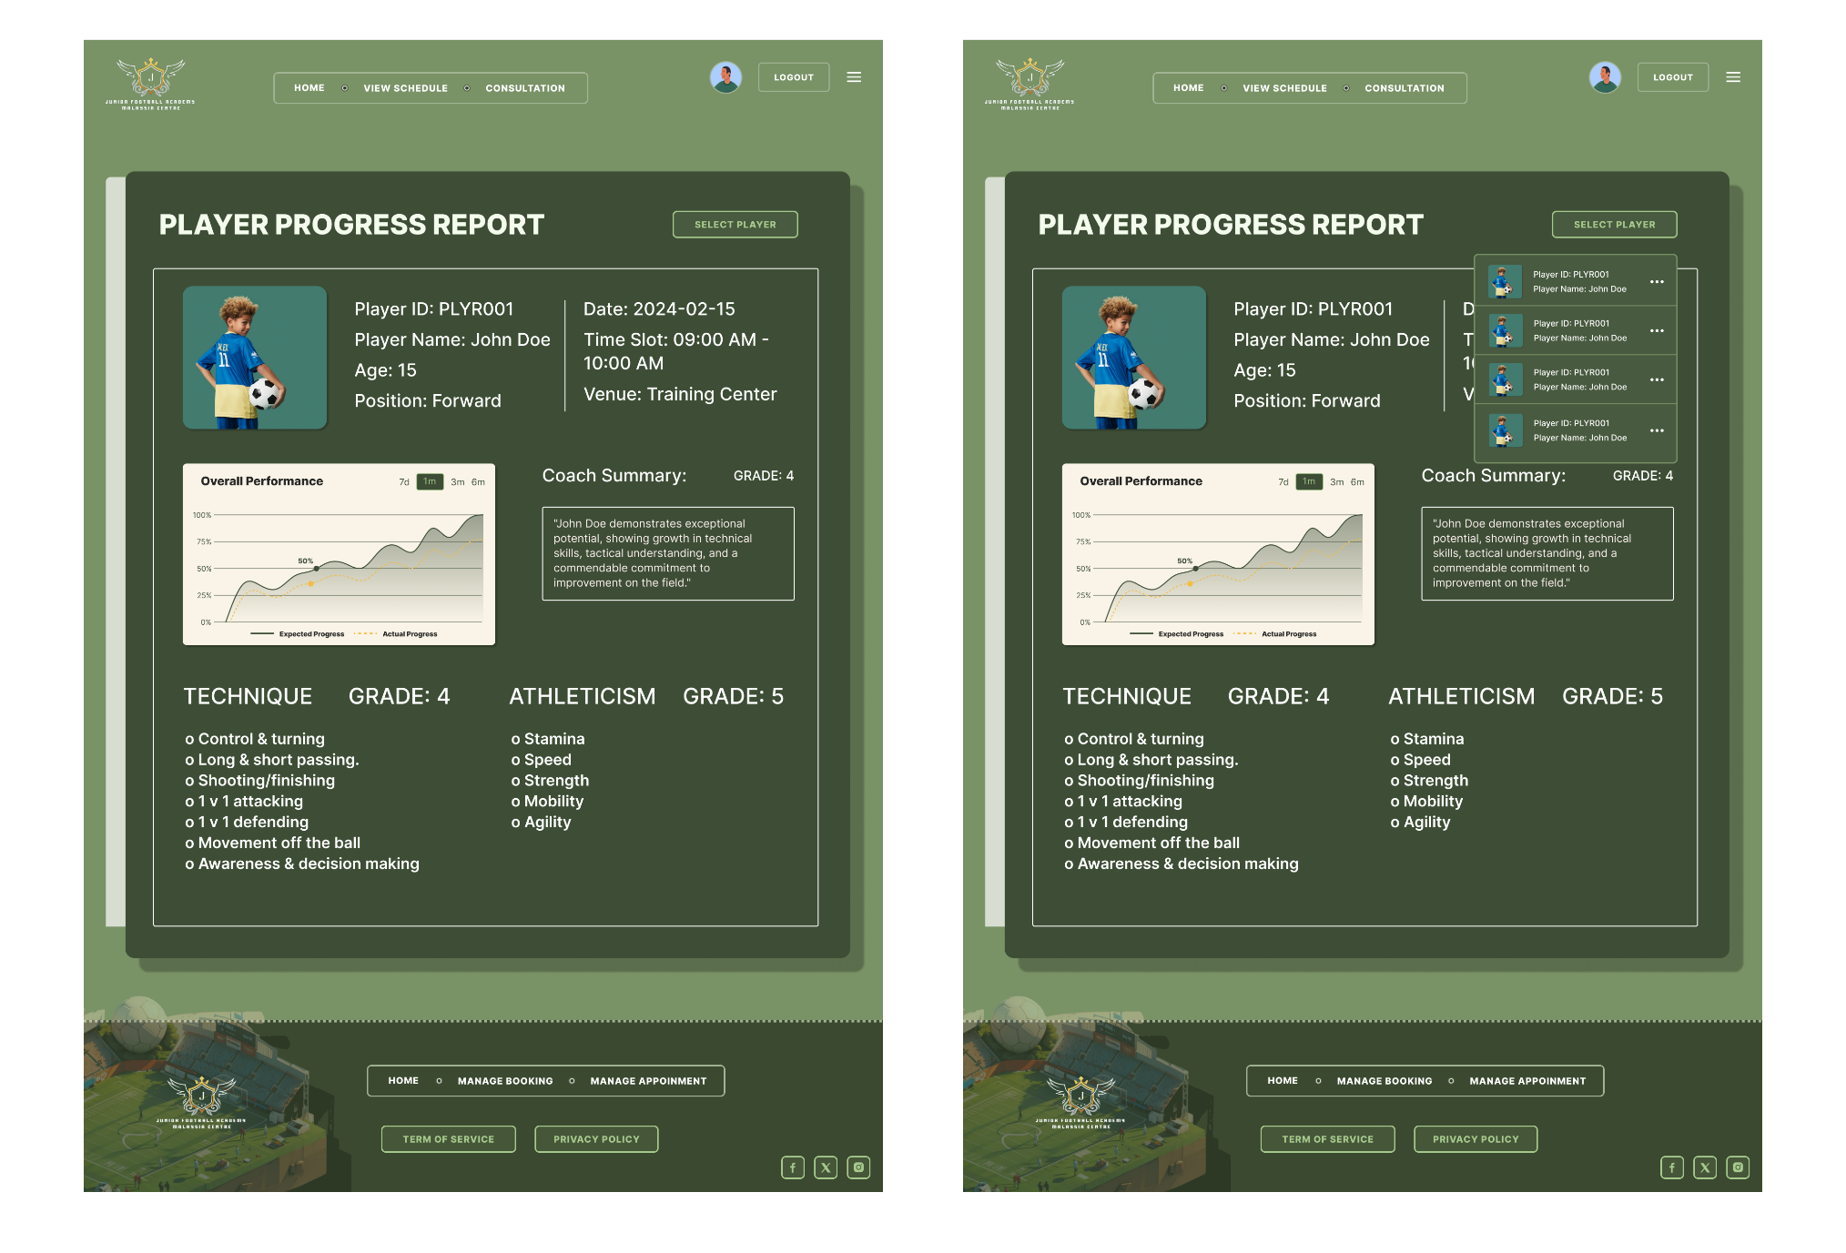

Figure 29: Player Progress Report Page

## 6.4 Owner

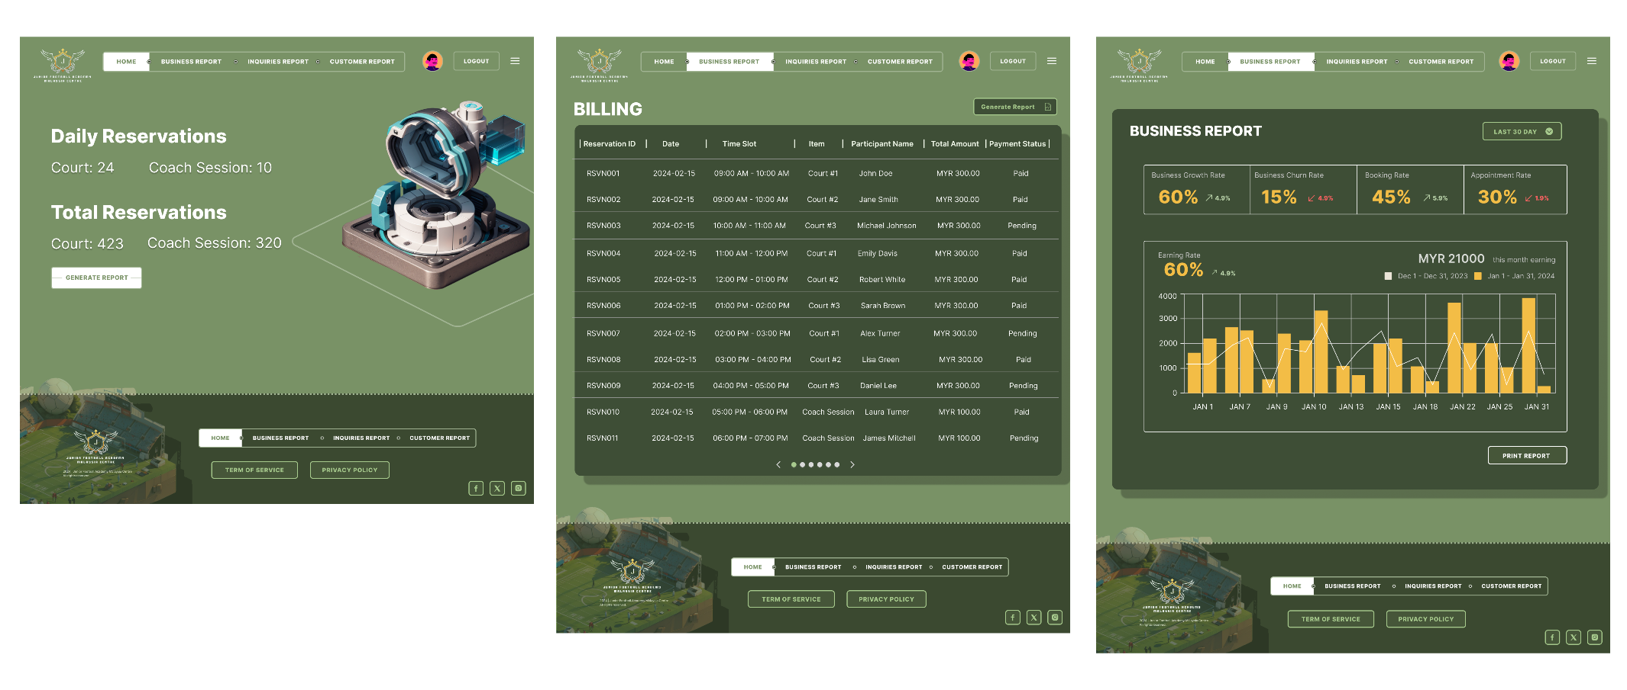

Figure 30: Owner Home Page, and Generate Report Page

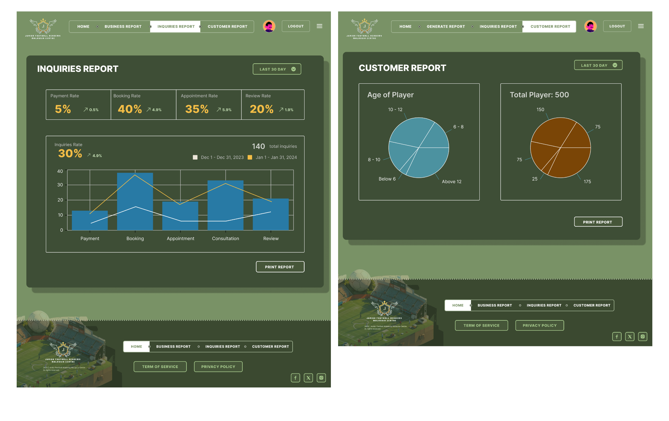

Figure 31: Inquiries Report, and Customer Report

# 7.0 Conclusion

To sum up the functional requirements we've discussed, give an overview of the project’s scope and the expected features of the proposed system. These requirements cover aspects, for the smooth operation of the academy center, including managing appointments, booking procedures coordinating schedules handling billing and payments generating reports, managing news and events providing professional consultation services creating personalized training plans and managing feedback and inquiries.

However, like any project there are limitations and challenges that may arise during implementation. These could include constraints, complexities in integrating with existing systems and ensuring security measures to protect sensitive customer data. Additionally, there may be challenges in training users to adapt to the system.

Moreover, for improvements of the system it could be beneficial to explore integrating intelligence algorithms. This could optimize appointment scheduling. Refine training plans based on performance data to enhance overall user experience. Considering integration with emerging technologies and providing updates to meet evolving user needs should also be considered.

In conclusion, while these functional requirements lay a foundation for the project’s success it is important to address potential limitations, overcome challenges and seize opportunities for improvement. This will ensure that the system remains effective in meeting the changing needs of both the academy center and its stakeholders over time.

# 8.0 Individual Component

## 8.1 CHOK JUNG SHING (TP070674)

### 8.1.1 Activity Diagram (Make Inquiries & Consultation)

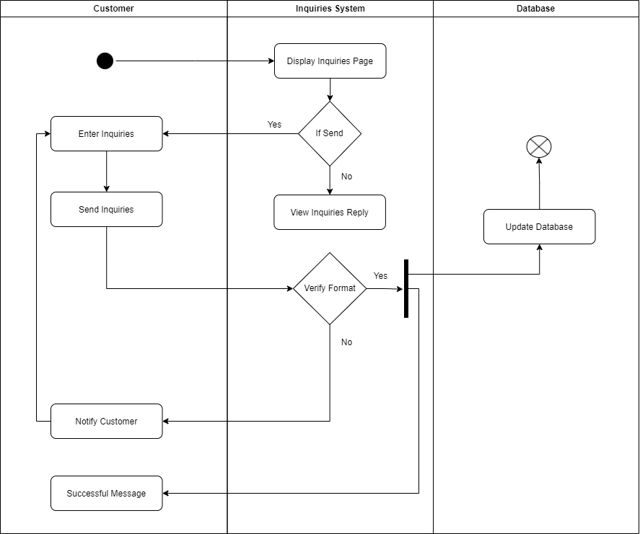

Figure 32: Make Inquiries Activity Diagram

Customers that land on the “Inquiries” page will have to choose between “Send Inquiries” or “View Inquiries Reply”. Choosing “Send Inquiries” will require customer to enter the information, then click send inquiries. If the format is correct, the system will update the database which also means that the message is successful. If the message is not successful, the system will notify the customer and return back for customer to re-enter the information. If customer select “view inquiries reply”, customer will then be directed to a page that can see the previous inquiries reply.

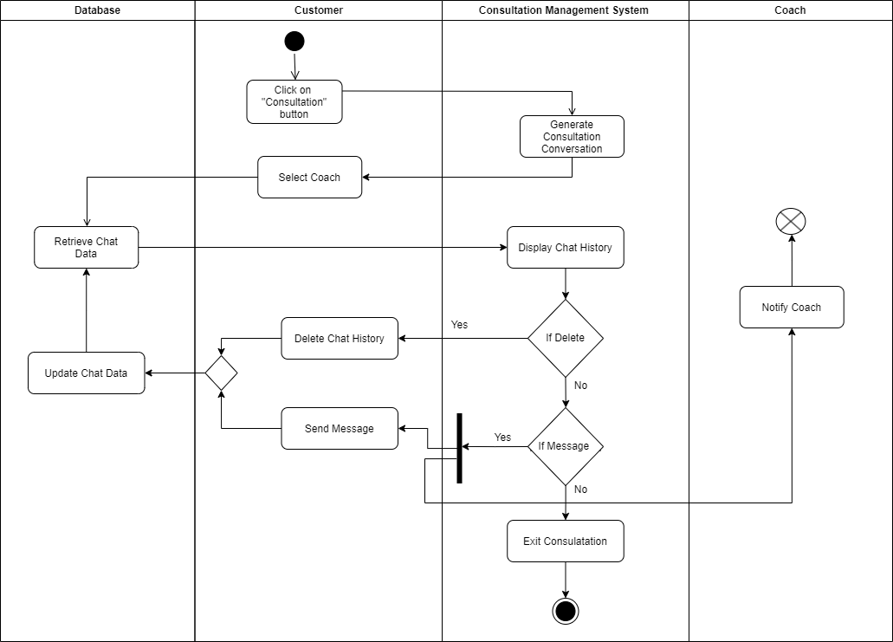

Figure 33: Make Consultation Activity Diagram

For customers that land on Consultation page, the system will initiate a consultation conversation between both customer and the selected coach from the customer. Then, the data chat will be retrieved, and the system will display the chat history on the web page. There will be options for customer to delete chat history or send message. If a customer decides to send messages, it will update the chat data to the database and notify the coach. And of course, if customer doesn’t take any action, the consultation would end.

### 8.1.2 Waterfall Methodology

This Waterfall Model methodology is suitable for the Junior Football Academy Malaysia Centre's information system development because of the simpleness and clear definition in each phase. This methodology aligns with the System Development Life Cycle (SDLC), and it is also a development process that will go through all phases (requirements, design, implementation, testing, and maintenance), with has to be completed before the moving to the next phase (Teams, 2022). And then, we will be applying this Waterfall Model into our information system development:

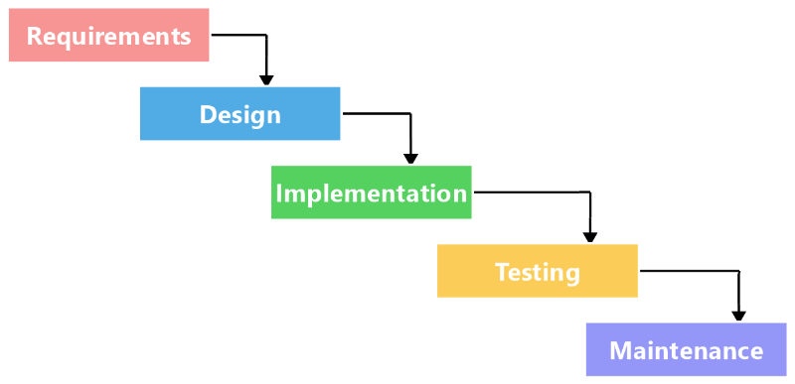

Figure 34: Waterfall Model

**Phase 1 – Requirement Definition**

In the starting phase, our team of business analysts will be engaging in an open conversation with Mr. Rajid and the receptionists. Then, we aim to gather the requirements for the new information system. Through several discussions, we had dig deep into the current manual processes, and focusing on how appointments are managed, training schedules are organized, and billing procedures are managed. The outcomes of these communications are carefully recorded down to ensure that all information is stated correctly. We will be also communicating widely open to quickly address any issues, building a solid foundation for the later development.

**Phase 2 – System and Software Design**

After gathering the knowledge during our requirements phase, the project can now smoothly move into the design phase. With the guidance by our experienced architects and team members, this phase will be about focusing the detailed plans for the functionality and in our software’s. We will pay close attention to create a blueprint that can meet the expectations of the Junior Football Academy Malaysia Centre. Our goal now is to ensure every aspect with the specific needs of the academy, setting up for a strong and efficient information system.

**Phase 3- Implementation and unit testing**

With the design that we have made, our development team will be bringing the plans to the coding. The development team will make sure that the actual plan will be followed and designed. On the other hand, our testing team will be testing the application continuously, to identifying any issues that arise. This repeated process will be ongoing until the application is sturdy.

**Phase 4- Integration and System Testing**

In this phase, we bring those components that has developed during implementation together into a complete system. Multiple testing is conducted to identify any potential faults or failures. After integration, the system will be undergoing thorough testing to ensure the system works perfectly. Any issues that come up are quickly dealt with, ensuring a much more reliable and well-integrated system.

**Phase 5- Operation and maintenance**

Once the system is deployed for use, random issues may appear. To deal with these, we will be releasing patches to keep the system runs smoothly. Moreover, we will regularly update improved versions to the product. This will guarantee our system to be ongoing, ensuring the operation system stays effective.

**Advantages of Waterfall Model**

1. Structured Development Phases:

The Waterfall model is more of a straightforward approach, providing clear development phases and easy to understand. This can greatly benefit the Junior Football academy by ensuring a well-organized and systematic implementation of the information system.

1. Clearer Defined Requirements:

In the Waterfall model, the project requirements will be documented and identified at the start of the project. This gives advantage for the football academy, guaranteeing that all necessary functionalities and features are known from the beginning.

1. Ease of Management:

With each phase having specific result, managing and tracking progress becomes more straightforward for Mr. Rajid and his team. This approach will aid in project control, ensuring it stays on schedule and updated.

1. Prioritize on Documentation:

The Waterfall model will prioritize the documentation throughout the development. This is good and beneficial for the football academy in terms of maintaining records, appointment schedules, training sessions, and billing details.

**Disadvantages of Waterfall Model**

1. Inflexibility to Changes:

A significant disadvantage of the Waterfall model is that the difficulty and costly to make changes once development begins. For the football academy, this could meet potential issues and cause extra costs if any enhancements are needed after the project starts.

1. Delayed Deliverables:

As the project progresses through the phases, deliverables for each phase are only produced only after the completion of the each previous one. This could give disadvantages for the football academy if they urgently needed a function or a feature, as they must wait until the entire system is developed (Team, 2023).

1. Feedback Timing:

The Waterfall model involves obtaining customer feedback at the project's end. In the football academy's case, this could be a disadvantage for Mr. Rajid as he might not see any functional components until the final stages, this could potentially lead to unsatisfied functionalities in the final results.

1. Risk of Misalignment with Business Needs:

If the requirements at the start are undefined clearly, the final system may not meet the actual business needs of the football academy. Hence, the risk in the Waterfall model will be much more challenging once the project is progressing (Laoyan, 2022).

1. Extended Development Time:

Due to the reason that the Waterfall model is a step-by-step process, it oftens used up lots of time during the development progress. For the football academy, this issue might cause a delay in implementing the system and for further improvements during business process will be delayed.

### 8.1.3 Functionality Testing (Make Inquiries & Consultation)

**Justification for Ensuring Smooth Inquiry Submission:**

The functionality steps are important to ensure that our “Submit Inquiry” functions will work correctly. It verifies users to submit inquires without facing any errors and to ensure the system works perfectly fine.

**Relevance in Making Inquiries & Consultation Page:User Reliance:** Users visiting the "making inquiries & consultation" page will rely on the functionality to submit their inquiries effectively. The submission process has to be effective so that users do not face any issues or errors during the submission.

**Data Accuracy:** Ensuring data will be accurate during the submission of inquiries. Customers information has to be processed accurately, to avoid any errors or glitches during the submission process that will lead to user frustration and loss of trust.

**Justification for Validating Consultation Form Fields:**With functionality testing method, it can validate the consultation form fields. Ensuring the required information will be input correctly. Proper handling of data types and input validation in our database system.

**Relevance in Making Inquiries & Consultation Page:Effective Consultations:** Customers on "making inquiries & consultation" page will need to provide related and accurate information for consultations. Validating the form fields can ensure customers input the information correctly, and to prevent accidental errors during the input that will affect the consultation process.**User Confidence:** During consultation process, customer will have confidence on the system's ability to handle their inquiries correctly. With no errors and smoother operations makes it more reliable of the consultation service.

**Test Script: Make Inquiries**

|  |  |  |  |  |  |  |
| --- | --- | --- | --- | --- | --- | --- |
| Test Case | Test Unit | Test Procedures | Test Data | Excepted Result | Actual Result | Status |
| TS001 | Customer can interact with the “Inquiries Page” | 1. Navigate to the "Inquiries" page on the customer’s portal. | Customer portal of URL | The "Inquiries" page should display the options "Send Inquiries" and "View Inquiries Reply”. | Options "Send Inquiries" and "View Inquiries Reply" are displayed. | Pass |
| TS002 | Customer selects "Send Inquiries" option | 1. Click on the "Send Inquiries" option. | Valid customer inquiry information | The system should update the database, and a success message should be displayed. | Database is updated, and the success message is displayed. | Pass |
| TS003 | Customer selects “Send Inquiries” option with incorrect format | 1. Click on the "Send Inquiries" option. 2. Enter invalid inquiry information (e.g., missing required fields, incorrect email format). 3. Click on the "Send Inquiries" button. | Invalid customer inquiry information | The system should notify the customer of the incorrect format and prompt to re-enter the information. | Error message is displayed, prompting the customer to re-enter the information. | Pass |
| TS004 | Customer selects “View Inquiries Reply” option | 1. Click on the "View Inquiries Reply" option. 2. Validates the page that displays previous inquiries and their replies. | None | The page should show a list of previous inquiries and their current replies. | Previous inquiries and replies are shown. | Pass |
| TS005 | Customer leaves fields empty in “Send Inquiries” | 1. Click on the "Send Inquiries" option. 2. Leave required fields (e.g., name, email, message) empty. 3. Click on the "Send Inquiries" button. | Empty customer inquiry information | The system should notify the customer of missing information and prompt to re-enter the required fields. | Error message displayed, prompting the customer to re-enter missing information. | Pass |
| TS006 | Customer views "Inquiries" page without selecting an option | 1. Navigate to the "Inquiries" page on the customer portal. 2. Do not select either "Send Inquiries" or "View Inquiries Reply." | None | The system should display the "Inquiries" page with both options visible. | Options "Send Inquiries" and "View Inquiries Reply" are visible. | Pass |

**Test Script: Consultation**

|  |  |  |  |  |  |  |
| --- | --- | --- | --- | --- | --- | --- |
| Test Case | Test Unit | Test Procedures | Test Data | Excepted Result | Actual Result | Status |
| TS001 | Customer initiates a consultation conversation. | 1. Navigate to the Consultation page. | N/A | * The Consultation page is accessible * The "Start Consultation" button is visible and functional. * The system initiates a conversation between the customer and the selected coach. | The Consultation page is accessible; the “Start Consultation” button is visible and functional; the system initiates a conversation between the customer and selected coach. | Pass |
| TS002 | Displaying chat history on the web page | 1. After initiating the consultation, check if the chat history is displayed on the web page. | N/A | * The chat history is displayed on the web page. * It includes messages from both the customer and the coach * The chat history updates in real-time. * The chat history remains visible during the entire consultation. | The chat history is displayed; it includes messages from both parties; it updates in real-time, and it remains visible. | Pass |
| TS003 | Customer options for chat history management | 1. Check for options to delete chat history on the web page. | N/A | * Options to delete chat history are available. * A confirmation prompt appears after clicking the "Delete Chat History" button. * Selecting "Yes" deletes the chat history. | Options to delete chat history are available; a confirmation prompt appears, and selecting "Yes" deletes the chat history | Pass |
| TS004 | Customer sends a message and updates the chat data | 1. Compose a message in the chat. 2. Click on the “Send Message” button. | Sample message from the customer | * The message is sent successfully. * The chat data is updated in the database. * - The coach receives a notification about the new message. | The message is sent successfully; the chat data is updated, and the coach receives a notification. | Pass |
| TS005 | Consultation ends if the customer takes no action | 1. Wait for a predefined period without any customer action. | N/A | * The system automatically ends the consultation if the customer takes no action | The system automatically ends the consultation if the customer takes no action. | Pass |
| TS006 | Coach receives a notification upon a consultation request. | * Initiate a consultation request as a customer. * Verify that the selected coach receives a notification. | N/A | * The coach receives a notification about the new consultation request. | The coach receives a notification about the new consultation request. | Pass |

## 8.2 LEW WAI HAO (TP071331)

### 8.2.1 Activity Diagram (Login and Register & Payment Processing)

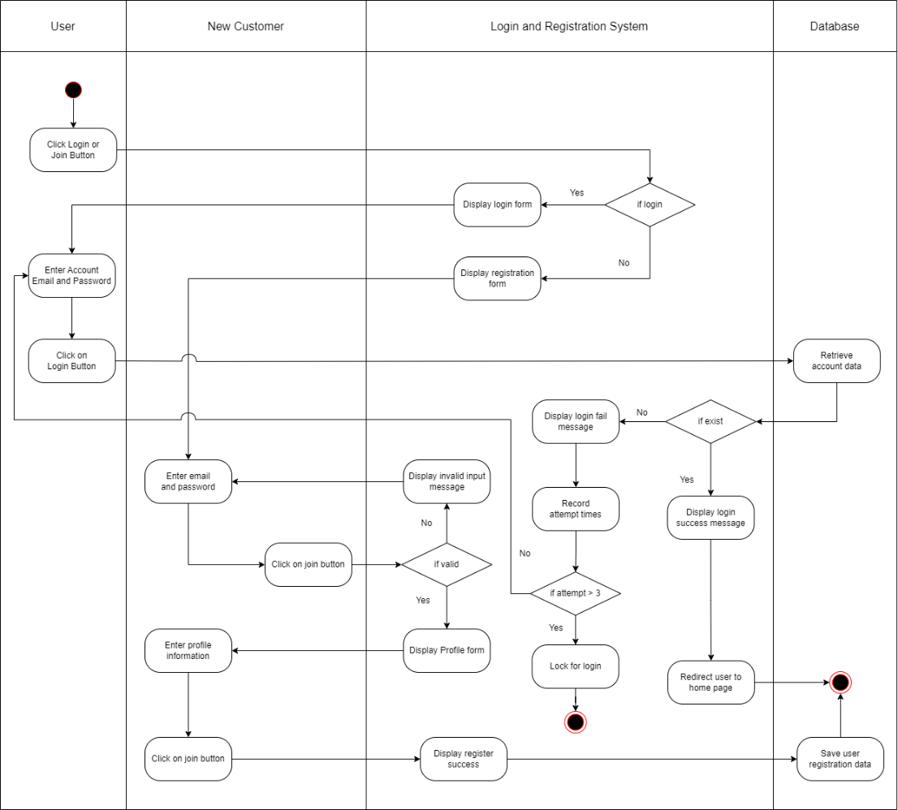

Figure 35: Login and Register Activity Diagram

Users are required to click either the "Login" or "Join" button to access the respective pages. Upon clicking the button, the system will display a specific form based on the user's selection. For new customers looking to register, the system will prompt them to enter their email and password. The registration system will then verify the input's validity. Once validated, new customers will be prompted to fill out their profiles. Clicking the "Join" button will call the system to display a registration success message and store the registration data in the database. On the other hand, users seeking access to the football management system must enter their account email and password. After entering the credentials, clicking the "Login" button will submit the input to the database for account data retrieval. If the entered email and password match an existing account, the system will confirm the existence of the account. Otherwise, it will indicate that the account does not exist. Upon successful login, the system will redirect the user to the home page. Once user attempted three times login within a short period, they are not allowed to make login requests for a specific time frame.

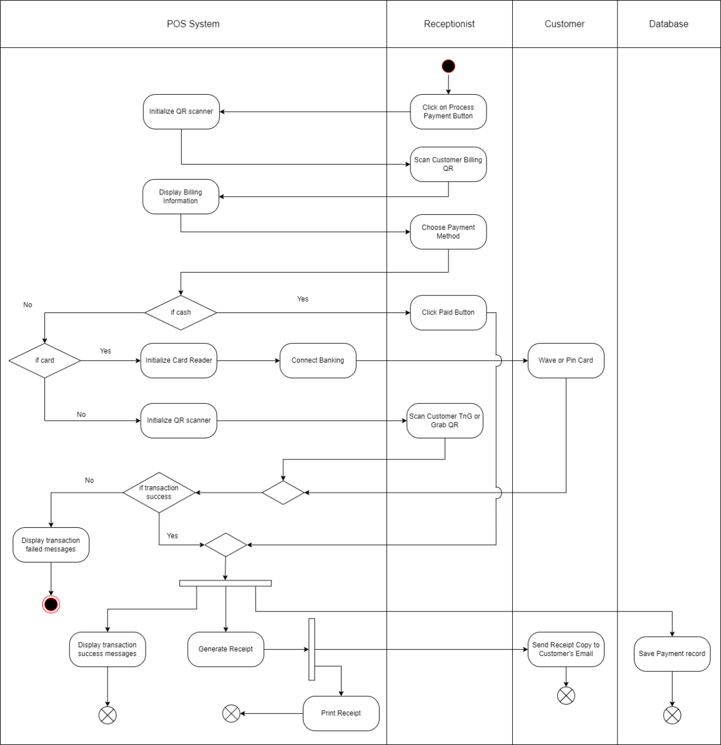

Figure 36: Payment Processing Activity Diagram

When the receptionist is ready to process payments, the QR scanner is activated to obtain customers’ billing information through QR code. The receptionist can then choose specific payment methods based on the customers’ preferences. For cash payments, the receptionist clicks the “Paid” button after receiving the cash. Alternatively, for credit or debit card payments, the system initializes the card reader and establishes connections with the banking system. Once the card reader is ready, customers can either wave or insert their card to facilitate transactions. Similarly, customers opting for payment through GrabPay or Tng Ewallet need to display their respective QR codes to the receptionist, who then scans them for transaction processing. Both card and QR payments may require confirmation from a third party. Upon successful transaction completion, the system displays a transaction success message, generates and prints a receipt, send receipt copy to customer’s email and documents the payment record in the database.

### 8.2.2 Rational Unified Process

Rational Unified Process (RUP) is a famous iterative software development methodology which designed by IBM Rational. It serves for object-oriented models, as known as the Unified Process Model. This methodology offers a disciplined software process framework to allocate task in a development team that provide standard guideline to ensure the development process effectively. (Kanjilal, 2022) In order to develop the football academy management system, it is suggested to use Rational Unified Process as development framework. This is because there are three practices that may help to improve the effectiveness of developing football academy management system.

1. Iterative and incremental development process

RUP places a spotlight on the iterative nature of work, advocating a cyclic approach rather than a linear progression from start to finish. It systematically divides the project into smaller cycles. When complete a circle, it might produce an executable program. The program should be evaluated and assessed risk before entering the next circle. For example, in the context of implementation, RUP suggests breaking it down into several smaller parts. In the first iteration, developers might focus on creating the basic structure and navigation of football academy website. In the next iteration, it can introduce additional features like user authentication, user registration and so on. Across multiple iterations, the system evolves from low-level to high-level state, gradually meeting all requirements. This iterative methodology allows for seamless adaptation to changes, ensuring that the development process remains dynamic and responsive to evolving project needs.

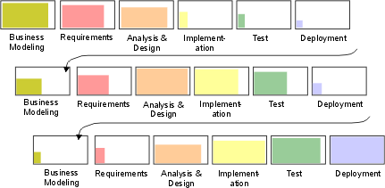

Figure 37: Iterative and incremental development process

2. Requirement management

It is known that requirements are impossible to completely gathered at the initial phase of development. Business requirements and user requirements often undergo frequent changes during the development process. For example, the receptionist of the business might provide ambiguous requirement on managing the operation activities. RUP place significant emphasis on effective Requirement Management, which iterative nature permits adaptability to changes throughout the development process. By meticulously keeping track of the requirements associated with each role involved in the system, RUP ensures a clear understanding of user needs. (Kanjilal, 2022) This comprehensive approach enables the football academy management system to efficiently carry out necessary operational activities and deliver the desired services, aligning closely with the evolving expectations of both the business and end-users.

3. Components-based architecture

Component-Based Architecture (CBA) serves as a design framework that conceptualizes each function as an independent component or module. According to Kanjilal (2022), it offers a method for software creation by utilizing existing components rather than reconstructing identical ones. Rational Unified Process (RUP) endorses the concept of CBA, emphasizing the development of software through reusable modules. For instance, a development team creating a football academy management system can design several components to provide essential features. These may include a login component for user authentication and access control, a calendar component for scheduling bookings and appointments, a history log component to track user activities like payments, inquiries, and scheduling, a reporting component for visualizing and analysing financial data, customer feedback, and customer records, and a messaging component facilitating communication between players and coaches.

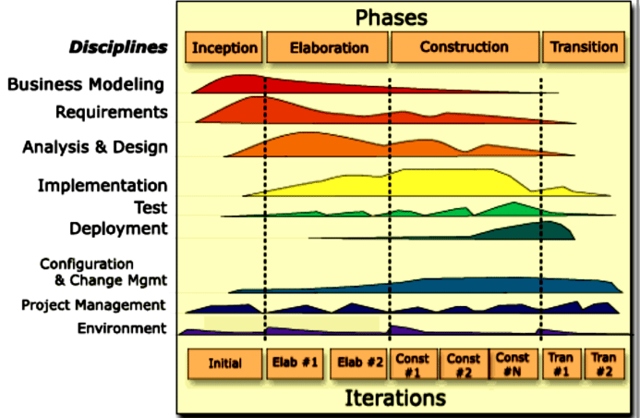

Figure 38: Components-based architecture

According to Janse (2019), RUP introduces two key elements in the development process which are static aspects and dynamic perspectives.  The vertical dimension, shown in the figure above, describes the static element of the process, including activities, artifacts, and workflow. Meanwhile, the horizontal dimension, also illustrated in the figure, represent the dynamic view of the system development lifecycle, divided into four phases: inception, elaboration, construction, and transition. At the end of each phase, there is a milestone which like a checkpoint to allow developers to review completed tasks against the requirements.

**Inception Phase**

In this phase, the development team is focusing on building the preliminary system model. (Taylor, 2022)This involves defining the objectives of the new system, identify the drawback of current manual system, finding out the solution for the problem and planning budget proposal. A business model must be identified first to understand the relationship between the football academy centre and the customers. This model describes who is the target customer, what is the value deliver to customers and how the business obtains revenue. The development team need to collect Mr. Rajib’s requirement, his employees’ requirements, customers’ requirements, and his business goal to determine the function of the football academy management system. Moreover, the development team may create a preliminary logical design to identify basic function of the management system based on gathered requirements. This may include how users’ access to the system, what tasks are managed by receptionist and how the customer communicates with coaches and receptionists. Not only that, but they also define the objective of prototype and identify the user interface of the new system. This may help to create a prototype more efficiently in the next phase.

**Elaboration Phase**

During the elaboration phase, the development team may conduct deeply study on business modelling and requirement. They refine and clarify the system requirements based on feedback received during the inception phase. This is because users’ requirements frequently change that may cause the requirement identified does not fulfil the business operational requirements. For example, Mr. Rajib wants to add a new feature into the system to attract customers’ attention on their business. Upon of this requirement, the development team identify a news and event feature which enables customers to follow the competition and activities in the football academy centre through the new system.

Furthermore, risk identification and assessment will be conducted during this phase to discover the potential risk associated with the new system. Since most of the players are underage, they may create a privacy policy and ensure the way of storing data comply with data protection laws. Moreover, components design, and database design should be defined before going to next phase. Components design represents a detailed system component, it can visualize the processes through context diagram and data flow diagram. These diagrams describe the external entities, processes, data flows and data stores within the new system. To conduct database design, the development team required to define the database structure, including tables, attributes, and constraints. An entity relationship diagram (ERD) can represent the interactions between each entity and describe their relationship. For instance, one customer can make one or many booking and each booking can generate a billing to customers for payment.

**Construction Phase**

In construction phase, the development team concentrates on convert the design that structed during elaboration phase to executable program. They may refer to the business model, requirements, and design diagram as blueprint for the construction phase. They can create prototype that defined during previous phase. (Taylor, 2022) This prototype may include the user interface of login page, organized report structure in report generation page, navigation bar, the input and output of making appointment and so on. They can select the suitable programming language and tools that used for coding efficiently. Since the new system is website-based software, it is suggested that utilizing HTML for building the structure, CSS for describing how the website displayed on, JavaScript for managing interaction, Node.js runtime for handling request and MySQL for storing, retrieval and managing data. Upon coding the programs, testing is compulsory to ensure the quality of software. Unit testing will be conducted to verify the functions of individual components or units of code independently and isolated. This testing includes verify user authentication, billing generation, report analysis and visualization and so on. In order to ensure the effectiveness of the software, the development team document all discovered bugs to identify the tools and methodologies used for debugging and troubleshooting. This process may not complete once, rather be it continues iteratively throughout the coding and testing phases. This is because new errors may surface during this ongoing debugging and troubleshooting process, even as the team works to address and resolve the previously identified bugs.

**Transition Phase**

Deployment planning will be carried out in this phase for preparing delivery the software to customers. This planning includes environment verification, configuration management and user guideline. Environment verification ensure that all required tools and the production environment are ready to install the new system. The football academy management system is connected to several external system such as database, and schedule management system to provide desired service. Therefore, they should configure the connection of database for ensuring the interaction between them and manage API configuration for enabling the system communicate with schedule management system. In addition, the development team should outline a user guideline to inform user about the software installation requirement, features and services within the system.

### 8.2.3 Security Testing

Security testing is a crucial testing method to verify the security strength of the entire system. It can identify the potential security issues that may cause data losses or malicious program access. This method guarantees the software against from malware infection, unauthorized access, data breach and data theft. (HackerOne, n.d.)

Benefit of Security Testing

1. Protect sensitive data

Security testing can identify and address vulnerabilities that could potentially lead to unauthorized access. This may help maintain the confidentiality of sensitive data and prevent data loss and falling into others. For example, it validates the effectiveness of encryption algorithms utilizing to safeguard sensitive data such as payment request, login request and user’s registration data during storage, transmission and processing.

2. Maintain data integrity

Security testing is able to avoid any invalid input access to the system. It focusses on the data-handling procedures and input validation mechanisms to verify the system whether can distinguish between authentic and fraudulent data. When processing a login request, for example, it makes sure the system recognizes and rejects potentially dangerous information.

Testing Conduction Process

1. Testing Scope Definition

First, it is necessary to specify the areas that need to be evaluated and the scope of the security testing. It aims to ensure security measures work inside the specified system bounds. Essential domains such as data storage, network connection protocols, workflow for payment processing, and authentication techniques are all included in the testing scope because they may have high potential security risk.

2. Test Environment Setup

A controlled testing environment is created after the scope definition so that security tests may be carried out there without impacting the live system. The purpose of this environment is to separate testing operations in order to get rid of any potential weaknesses in the active system. To further guarantee the strong security of the system, testing resources and tools like Open Web Application Security Project (OWASP) and network monitoring tools are carefully chosen.

3. Test Planning

During this step, a comprehensive test plan that encompasses the methodology, test data, and expected outcomes is developed. A detailed schedule for the test stages is also included in the plan, guaranteeing that each test case is completed within the allotted time.  In addition, in order to make sure that the test precondition falls within the intended range, we need to elaborate on the guidelines and testing procedure in detail.

4. Execution of Security Tests

Security tests are carried out according to the predetermined plan after the test planning stage. Techniques like vulnerability scanning, penetration testing, and other simulations that reflect real security risks are used. To evaluate the effectiveness of implemented security measures, relevant information such as hashed password after registration and third-party confirmation responses is gathered and the system's response to security tests is tracked. Any variations from the expected outcomes will be noted for further examination.

5. Validation of Results

After gathering all testing results, they are validated and compared to the expected results defined in the testing plan. If there is significant variability between actual and expected results, the test may be labelled as failed, prompting risk assessments. Based on the risk assessment, identified vulnerabilities are evaluated and prioritized according to potential risks to the system.

6. Documentation and Review

The entire security testing process is documented for future reference. The document includes identified vulnerabilities, their potential impact, and suggestions for addressing them. This documentation is shared with Mr. Rajib for feedback and to make necessary improvements for future security testing processes. The collaborative review ensures continuous enhancement of the system's security measures.

Test Script for Security Testing

|  |  |  |  |  |  |  |
| --- | --- | --- | --- | --- | --- | --- |
| Test Cases | Test Unit | Test Procedure | Test Data | Expected Result | Actual Result | Status |
| T100 | Input Validation for email and password | 1. Click on “Join” button. 2. Enter a potentially SQL injection input with special characters. 3. Attempt to submit the input | Email: OR 1=1  Password: + or || | The system should validate input and filter the input and displaying a relevant error message | The system display “Invalid email and password” and prompt user to re-enter the email and password. | Passed |
| T101 | Password Hashing | 1. Click on “Join” button. 2. Register as a new customer. 3. Submit the password and store into database. 4. Check how passwords are stored in the database | Password: Abc123@123 | Password should be securely hashed in the database, ensuring that even admin cannot view plaintext passwords. | The system uses Secure Hashing Algorithm version 2 to hash passwords and digest them into hexadecimal before storing them in the database. | Passed |
| T102 | Login Process | 1. Click on “Login” button. 2. Enter email and password. 3. Click on the “Login” button to submit the input. 4. Monitor network traffic to ensure credentials are transmitted securely via HTTPS | Email: [receptionist@juniorfootball.edu.my](mailto:receptionist@juniorfootball.edu.my)  Password: Receptionist123@ | The system should use secure transmission (HTTPS) for user credentials | The network traffic analysis confirms that the credentials are transmitted securely using the HTTPS protocol. | Passed |
| T103 | Limit Registration Rate | 1. Click on “Join” button. 2. Attempt to register accounts. 3. Attempt to register second accounts. 4. Observing whether the system prevents registration after it reach the specific limit. | Account 1  Email: [ali@gmail.com](mailto:ali@gmail.com)  Password: Ali123@mohammad  Account 2  Email: jason@gmail.com  Password: Jason123@chong | The system should have rate-limiting measures for account registration to prevent an excessive number of registrations within a specific time frame. | The system unallowed user to make account registration after they registered 2 accounts within 1 minutes. The system allows registration after 30 seconds has passed. | Passed |
| T104 | Account Lockout | 1. Click on “Login” button. 2. Enter incorrect email and password three times. 3. Attempt to login again after the account is locked | Email: lily@gmail  Password: lily123wong | After three failed login attempts, the system should lock the login request for the user to prevent further login attempts within a specific time | The system increases the login attempt count after failed attempts. Once the count achieves three, it locks the user login request around 5 minutes. | Passed |

|  |  |  |  |  |  |  |
| --- | --- | --- | --- | --- | --- | --- |
| Test Cases | Test Unit | Test Procedure | Test Data | Expected Result | Actual Result | Status |
| T105 | Billing QR Scanner Activation | 1. Click on “Process Payment” button. 2. Activate the QR scanner. 3. Attempt to scan an invalid QR code. | Invalid Billing QR code | The system should handle the activation of the QR scanner securely, rejecting invalid QR codes and displaying an appropriate error message. | The system rejects the billing QR code, display an error message and prompting receptionist to re-scan QR code | Passed |
| T106 | Card Payment Initialization | 1. Choose card payment. 2. Initialize card reader. 3. Connect to banking. 4. Disconnect the network. 5. Monitor the payment environment. | N/A | The system should guarantee the card reader initialization securely and keep track the network situation, displaying an error message in case of failure | The system display “Network Interruption” on card reader when detect network instable by using network monitoring tool. | Passed |
| T107 | Card Payment Transaction | 1. Choose card payment. 2. Initialize card reader. 3. Insert invalid credit card. 4. Verify the validity of the card | 1. Expired date  2. Card Status | The system should ensure the validity of card during card payment process | The system identifies the card is inactive and have been expired. It terminates the payment process and display “Invalid Card” message on card reader. | Passed |
| T108 | Third-Party Payment Confirmation | 1. Initiate a card or QR payment transaction. 2. Encrypt the transaction request. 3. Send the transaction request to third party. 4. Monitor the request and response flow. 5. Receive third-party payment response | Card or QR transaction request | The system should securely handle third-party confirmation and display transaction failed when receive failure response from third-party | The POS system utilize TLS protocol to encrypt the payment request. The system can identify the confirmation response and display transaction failed if a failure response received | Passed |
| T109 | Email Receipt Delivery | 1. Complete a payment transaction within the POS system. 2. Generate receipt for the bill. 3. Prepare a receipt email. 4. Send email to customer | 1. Sender email address  2. Receiver email address  3. Email Title  4. Email Content  5. Receipt PDF file | The system should deliver the encrypted email receipt to customer to protect against security vulnerabilities. | The system utilizes SSL protocol to establish a securing internet connection between the system and customer encrypting the sensitive email content and confirming the PDF copies of the receipt are securely attached and not susceptible to tampering before sending it. | Passed |

## 8.3 LEONG SENG KHUAN (TP070856):

### 8.3.1 Activity Diagram (Generate Business Sales Report & Modify Player Progress Report)

**Generate Business Sales Report**

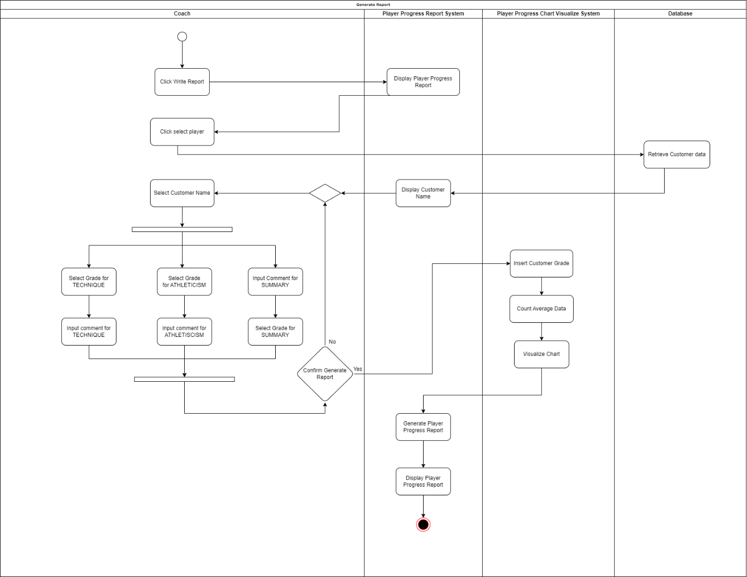

Figure 39: Generate Business Sales Report Activity Diagram

When the Coach intends to modify or assess a player's progress grade, Coach interact the process by clicking on the **"Write Report"** button located on the navigation page. It's important to note that this feature is exclusive to the Coach and accessible only through the navigation page.

Upon selecting **"Write Report"** button, the Coach is seamlessly redirected to another page showcasing the **Player Progress Report** interface. Upon this page, the Coach encounters the **"Select Player"** button positioned at the top right corner allows the Coach to choose player names from the database. The **Player Progress Report System** retrieves customer names from the database as a selectable player for the Coach.

Having selected player, the Coach will assign grades and provides insightful comments. Upon completion of this assessment, the Coach has the option to either affirm their choices by clicking the **"Done"** button or revisit the grades and comments for any necessary adjustments. Choosing for the **"Done"** button, it triggers the transmission of data to the **Player Progress Chart Visualize System**, where a comprehensive chart illustrating the player's progress is generated. Subsequently, the processed data is seamlessly transferred back to the **Player Progress Report System**, generate the **Player Progress Report** and display of the **Player Progress Report**. This workflow to ensure the efficient process for evaluating and documenting player progress within the coaching framework.

**Modify Player Progress Report**

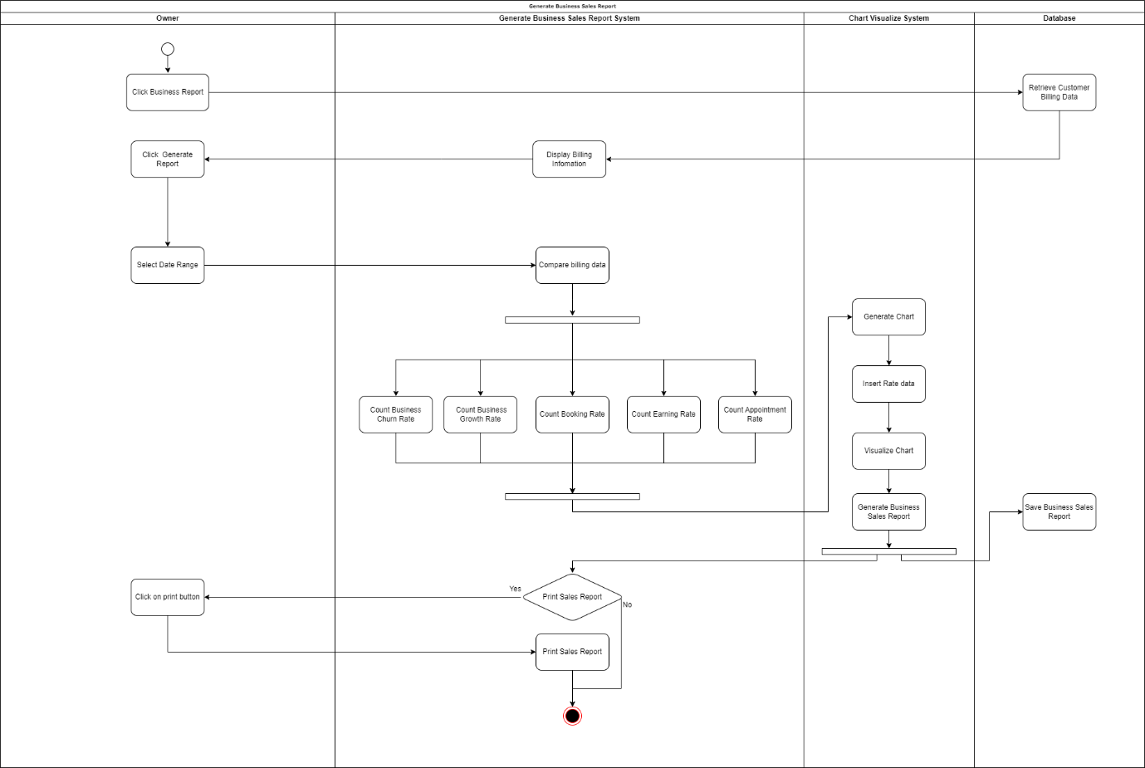

Figure 40: Modify Player Progress Report Activity Diagram

Upon Owner logging in, the owner initiates the receipt generation process by selecting the **"Business Report"** button positioned at the top of the page. This action triggers the retrieval of customer billing data from the database, then transfer to the **Business Sales Report System**. Here, a new page displaying about the billing information.

To proceed, the owner now will click on the **"Generate Report"** button located in the footer section. This action navigates them to another page, showcasing the **previous Business Sales Report** and a feature about **"Date Range"** button at the top right corner within a designated box. The owner then clicks on this button to choose specify date and month for generating the **Business Sales Report**.

After that, the **Generate Business Sales Report system** sets in motion a series of calculations. This involves **comparing billing data, calculating Business Churn Rate, Business Growth Rate, Booking Rate, Earning Rate**, and **Appointment Rate**. Once this calculations process is completed, the data transfers to the **Chart Visualize system**, where visually compelling charts are generated and then finalized Business Sales Report.

After finalized Business Sales Report, the latest data will store in the database. The owner is provided with the option to print a receipt. If the owner chooses to proceed, they simply click on the **"Print Receipt"** button located at the bottom right of the designated box.

### 8.3.2 Boehm’s Spiral model

Using the Boehm’s Spiral model for methodology may be perfectly fit in the Junior Football Academy Malaysia Centre. By using this methodology, it allows each loop in the spiral represents a phase in the process to minimize the risks. It is particularly suited for complex or risky projects where the requirements are not fully understood when have a large applications and systems which will be built-in small phases. Boehm’s Spiral model have 4 main phases which is **Determine Objectives Alternatives Constraints**, **Evaluate Alternatives Identify and Resolve Risks**, **Develop and Verify Next Level Product**, and **Plain Next Phases.** (GeeksforGeeks, 2023)

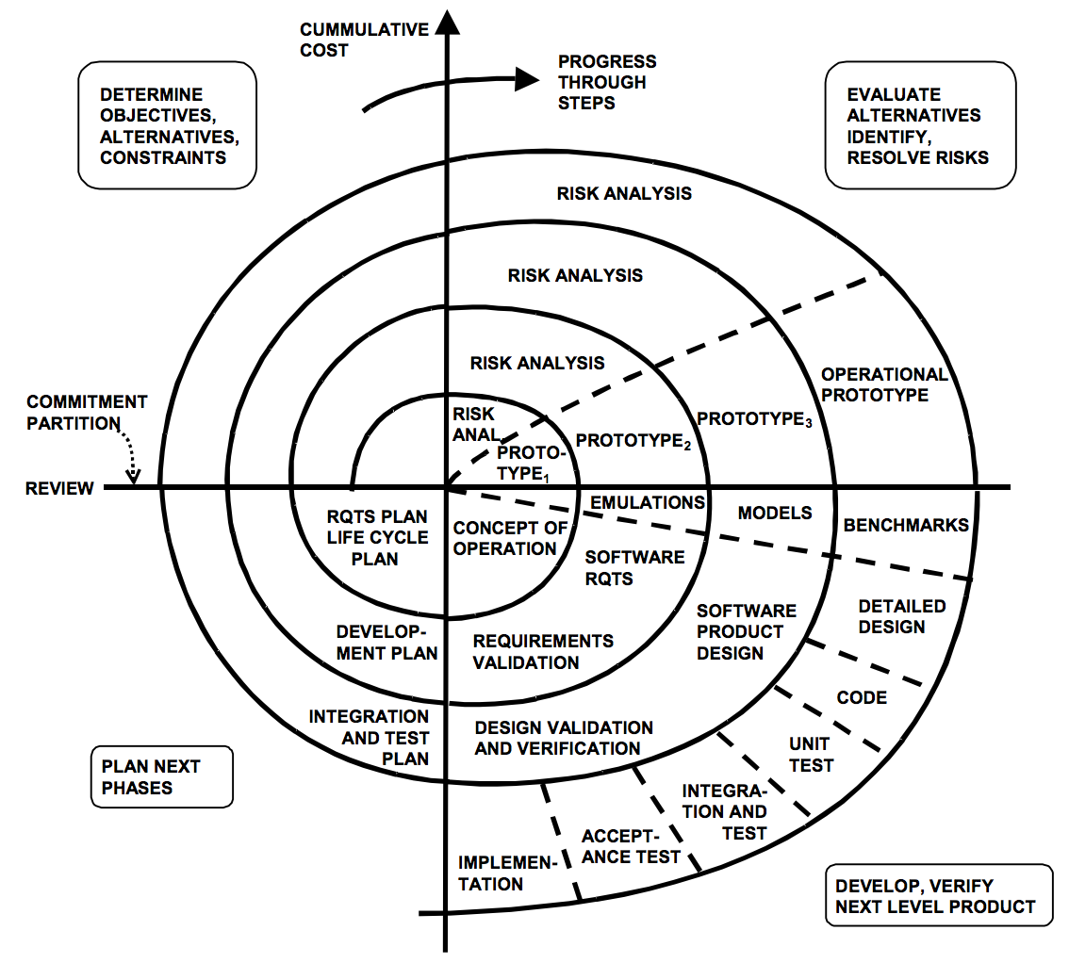

Figure 41: Spiral Model

**Phase 1 - Determine Objectives Alternatives Constraints**

In this phase, the Owner Junior Football Academy Malaysia Centre will determine the objectives for the project, such as the time, the budget, and the technological limitations. This helps owner to know what business model should run.

**Phase 2 - Evaluate Alternatives Identify and Resolve Risks**

After gathering the thoughts, the team evaluates the potential benefits, scalability, and a few guesses about its performance put in place to reduce the key risks. For this phase, the team may be creating prototypes to get a better understanding the trade-offs for each process on this project.

**Phase 3 - Develop and Verify Next Level Product**

Based on the evaluation, the team will select a strategy and begins to implement actual developments of software programming for this project and focus on the most significant impact for the project to meet the requirements and functions for this project to success.

**Phase 4 - Plan Next Phases**

After developing, the team will make a survey or review for this current project and afterwards, adjusting the plan based on the outcomes and may be reassess the project’s objectives and constraints the new information. The team then prepares for the next iteration process ensures continuous improvement by refining the objectives and update the next set of features to develop.

**Advantage of Boehm’s Spiral model**

1. This project may conclude many unknown risks that occur when the development proceeds, in that case, this spiral model helps this project to emphasizes the risk management throughout the project life cycle, which helps to minimize the impact of uncertainty and risk on the software development process.
2. By using this spiral model, you can change the request of the requirements flexibility at a later phase can be incorporated accurately.
3. It is recommended to use this spiral model when developing a large and complex project.
4. While the software development progresses, the spiral model provides for multiple iterations which can result in improved software quality and reliability.

**Disadvantage of Boehm’s Spiral model**

1. Boehm’s Spiral model is suitable for cost slightly expensive applications and large projects but is not suitable for small projects.
2. Boehm's Spiral model is too much dependability on risk analysing for the successful completion of the project. Without very highly experienced experts, using this model is going to be a failure to develop a project.
3. As the number of phases increases or decrease or unknown at the start of the project, it is difficult to estimate the time for the project. It may be taking a long time to finish the model, so that the product becomes perfect.

### 8.3.3 Usability Testing

Usability Testing is important for Generate Business Sales Report & Modify Player Progress Report because is to identify the service or product effectiveness, efficiency, and satisfaction of users when interacting with the system making it inclusive and accessible to users. In summary, usability testing is justified by its ability to create a more user-friendly software product that meets the user’s expectation.

**Test Scripts: Generate Business Sales Report & Modify Player Progress Report**

**Generate Business Sales Report**

|  |  |  |  |  |  |  |
| --- | --- | --- | --- | --- | --- | --- |
| Test Case | Test Unit | Test Procedures | Test Data | Excepted Result | Actual Result | Status |
| T001 | Display Player Progress Report | Log in as the owner and click on the "Business Report" button | N/A | The owner should be seamlessly redirect to a new page displaying billing information | Redirected to a new page and displayed billing information | Passed |
| T002 | Generate Report Button Visibility | Click on the "Generate Report" button located in the footer section and retrieve the data from the database | N/A | The owner should be redirect to another page showcasing the previous Business Sales Report | Redirected to another page with showcasing the previous Business Sales Report | Passed |
| T003 | Choose Date and Month | Click on the "Date Range" button and choose a specific date and month for generating the Business Sales Report | Date and Month | The system should provide a user-friendly interface for selecting the date and month, with clear instructions and feedback. | The system did provide a user-friendly interface for selecting the data and month | Passed |
| T004 | Business Sales Report Calculation | Initiate the "Generate Business Sales Report" system | Business Sales data | System calculates Business Churn Rate, Business Growth Rate, Booking Rate, Earning Rate, and Appointment Rate based on billing data and lastly compare billing data | The System did calculate for Business Churn Rate, Business Growth Rate, Booking Rate, Earning Rate, and Appointment Rate based on billing data and compared billing data | Passed |
| T005 | Data Transfer to Chart Visualize System | Verify the seamless transfer of calculated data to the Chart Visualize system | Business Sales data | Calculated data should be sent to the Chart Visualize system to visualize the chart | The system does visualize the chart | Passed |
| T006 | Finalized Business Sales Report | Check if the finalized Business Sales Report is displayed after the calculations | Business Sales data and Visualize chart | Business Sales Report Data and visual charts transfer back to Business Sales Report System, and should be generate a report | The system does generate the report | Passed |
| T007 | Print Receipt Functionality | Click on the "Print Receipt" button and verify the functionality to print a receipt and transfer the data to database | N/A | A receipt should be generated and ready for printing through a user-friendly process, ensuring ease of access and clear instructions. | The function works fine for printing receipt | Passed |

**Modify Player Progress Report**

|  |  |  |  |  |  |  |
| --- | --- | --- | --- | --- | --- | --- |
| Test Case | Test Unit | Test Procedures | Test Data | Excepted Result | Actual Result | Status |
| T001 | Write Report Button Accessibility | Click on the "Write Report" button located on the navigation page. | N/A | Coach is redirected to the Player Progress Report page | Redirected to a new page to display Player Progress Report | Passed |
| T002 | Select Player Button Visibility | Click on the "Select Player" button by retrieve customer name from database and display it | N/A | "Select Player" button and should be display the customer’s name as player | Showcased a ton of player’s name | Passed |
| T003 | Assigning Grades and Comments | Coach selected a player, assign grades, and provide comments | selected, grades, and comments input | Grades and comments should be successfully assigned | Grades and comments are successfully assigned | Passed |
| T004 | Confirmation with "Done" Button | Click on the "Done" button after completing the assessment. | Selected player, assigned grades, and comments | Data should be transmitted to the Visualize and Report Systems | Data is transmitted to the Visualize and Report Systems | Passed |
| T005 | Chart Visualization | Verify that a comprehensive chart illustrating player progress is generated | Selected player, assigned grades, and comments | Chart should be generated and clean information | It turns out that the chart is generated successfully | Passed |
| T006 | Player Progress Report Generation | Check that the Player Progress Report is generated and displayed and transfer the data to database | Selected player, assigned grades, comments, Visualize chart | Player Progress Report should be generated report and display after clicking “done” button. | Player Progress Report is generated and displayed as expected. | Passed |

## 8.4 TEH ZHONG CHENG (TP070872)

### 8.4.1 Activity Diagram (Manage News and Event & Make Booking)

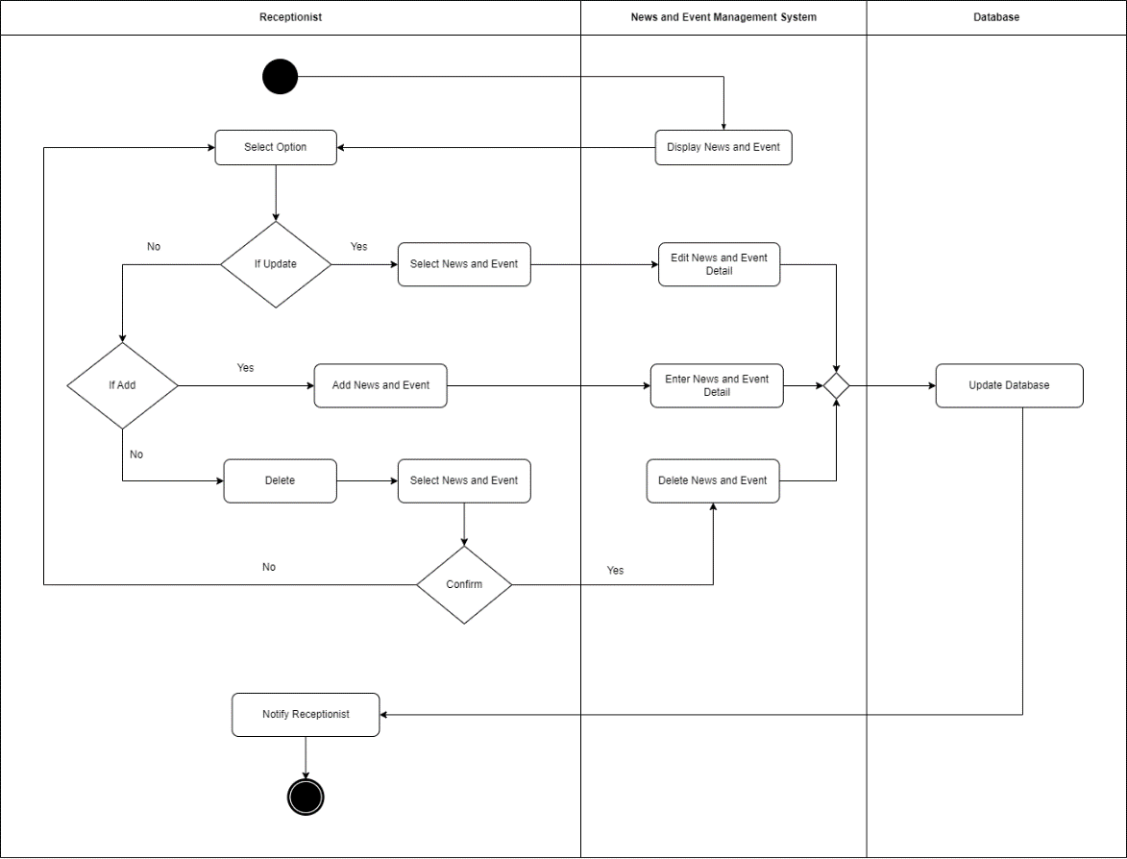

Figure 42: Manage News and Event Activity Diagram

Upon accessing the news and event page, the news and event management system will present the available news and events to the receptionist. The receptionist will then have the option to choose between updating, adding, or deleting content.

If the receptionist selects the "update" option, they will proceed to choose a specific news or event and navigate to the news and event management system to edit its details. In the case of choosing "Add," the receptionist will go to the news and event management system to input new details for the news or event. If "Delete" is selected, the receptionist will first choose a news or event, and then confirm whether they want to proceed with the deletion. If confirmed, the news and event management system will delete the selected news or event; otherwise, the receptionist can go back and choose another option.

Following these actions, any edits made to news and event details, additions, or deletions will be reflected in the database. Additionally, the receptionist will be notified of the changes.

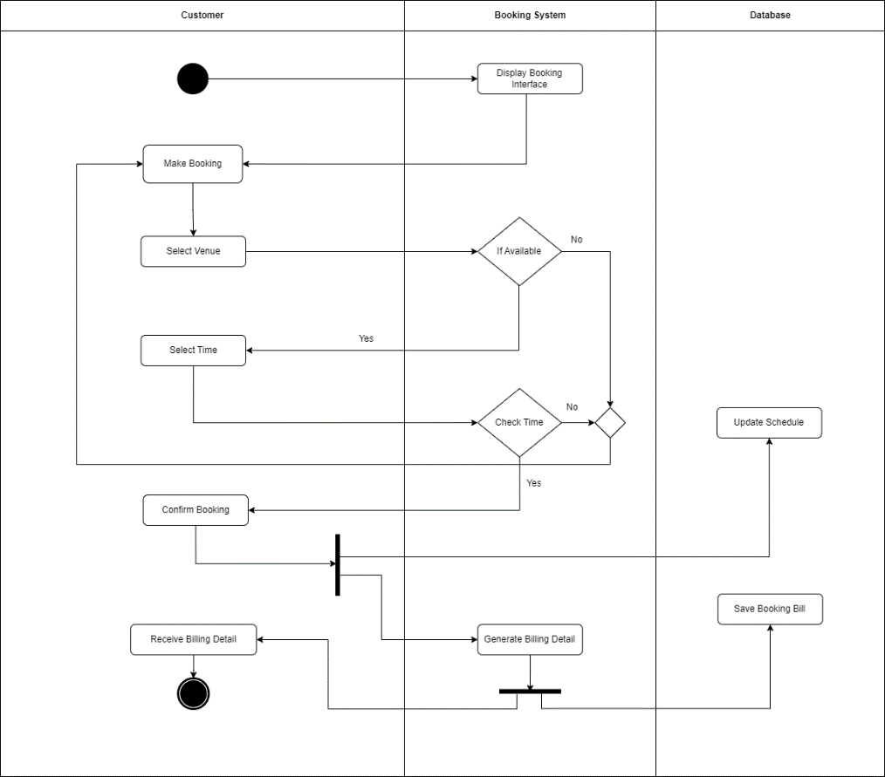

Figure 43: Make Booking Activity Diagram

When a customer accesses the booking page, the booking system will present the booking interface. Subsequently, the customer will proceed to make a booking, involving the selection of both the venue and the desired time. The booking system will then verify the availability of the chosen venue and check whether the selected time slot is open.

Following these checks, the customer will be prompted to confirm the booking. Upon confirmation, the booking system will update the schedule in the database and generate billing details. The generated billing information will be stored in the database for record-keeping purposes, and simultaneously, the customer will receive a detailed billing summary.

In summary, the customer's booking journey involves selecting a venue and time, verifying availability, confirming the booking, updating the database with the schedule, generating billing details, storing billing information, and providing the customer with a billing summary.

### 8.4.2 Prototyping

Implementing the prototyping methodology in the Junior Football Academy Malaysia Centre can identify the challenges and issues in the current manual system. The reason using prototyping is that it can allow communication between developers and customers, to ensure that the final result of the system meets the requirements and objectives of the football academy and to check for the idea. There are 4 categories of prototyping in this methodology which is throwaway prototyping, evolutionary prototyping, incremental prototyping, and extreme prototyping. (Lewis, 2023)

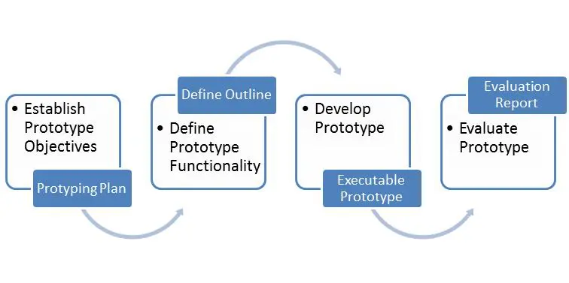

Figure 44: Prototyping Model

**Prototyping Phase**

1. Establish objectives:

Outline the goals and objectives of the prototype clearly. Identify those problems and to search for the target audience and their needs.

2. Define prototype functionality:

Specify the functionalities and the features that are going to include. Key elements must be prioritized on the objectives. Outline the requirements and limitations of the prototype.

3. Develop the prototype:

Choose the 4 categories of prototype approach which are throwaway, evolutionary, incremental, and extreme prototyping. Select the tools that are required to create the prototyping. Geeting feedback for refining the system development process.

4. Evaluate the prototype:

Conduct a testing to gather feedback on the prototype system.

**Advantages of Prototyping**

1. User Involvement:

In the context of the football academy, involving the receptionists, coaches, and Mr. Rajid in the prototyping process ensures that the system meets their specific needs. Regular feedback from end-users allows for adjustments to be made early on, leading to a system that aligns closely with the organization's requirements. (Walton, 2023)

1. Improved Communication:

Prototypes help stakeholders see and understand the proposed solution by providing tangible representations of the system. This helps technical and non-technical stakeholders communicate and comprehend the system's functions. (Sumon, 2023)

1. Adapting fast to changes:

Since the football academy's operations are dynamic, prototyping enables for quick adaptability to changing needs. As changes are made during development, the system can adapt to new features without substantial interruptions.

1. Risk Reduction:

Prototyping's iterative nature helps discover and mitigate risks early in development. Addressing schedule conflicts, data management issues, and user interface preferences sequentially reduces the risk of project setbacks.

**Disadvantages of Prototyping**

1. Time-Consuming

Prototyping is a time-consuming process because of its iterative character, which presents the possibility of extending the schedule for development. This constant refining is beneficial, but it may not fit tight project timeframes, especially if system deployment is critical. (T, 2023)

1. Potential for Scope Creep:

Frequent user input and revisions may lead to the project's objectives expanding beyond its initial limitations. If mishandled, this might raise complexity and expenses. (Webitlab, 2023)

1. Resource-intensive:

Creating numerous prototypes and incorporating input needs substantial time and energy. This might be difficult for smaller teams or projects with limited resources.

4. Incomplete Prototypes:

There is a possibility that the final system may not be in complete accordance with the initial vision. This is because each iteration may involve modifications that are different from the criteria that were initially established.

### 8.4.3 Load and Stability Testing (Manage News and Event & Make Booking):

Justification:

1. Simulating Managing News and Events at the Same Time:

Load testing is essential for modelling concurrent tasks like news and event management. News and events may be added, edited, and withdrawn. A high number of requests may be processed at once, reducing speed difficulties or delays during peak demand.

1. Handling Simultaneous Booking Requests:

Load testing is necessary to simulate multiple booking requests. The goal is to schedule football practice sessions concurrently. For consumers to have a smooth planning experience, the system must effectively handle these requests without issues. (What is Load Testing?, n.d.)

1. News and event management that runs all the time:

Continuous news and event management requires stability testing to be functioning. Add, change, or remove news and events. Stability testing discovers and repairs system-destabilizing memory leaks and resource concerns.

1. Dependability in the Booking Process:

Stability testing is essential for reliability. It keeps the system running when people book rooms and football training schedules alter. This reliability is required to keep correct and up-to-date information for both employees and customers.

1. Consistently Managing Edit and Delete Tasks:

Stability testing assesses the system's news and event editing and deletion capabilities. If a news and event management system is trustworthy and easy to use, these steps must be repeated without crashing or causing data inconsistency. (Hamilton, 2023)

1. Maintaining system performance during busy booking times:

Stability testing helps check system functioning during high booking volume. This keeps the system consistent even when numerous people reserve. Find and fix security risks despite high user experience expectations. (Hamilton, 2023)

In simple terms, load testing checks how well the system can manage lots of requests all at once, like when many people try to access news or make reservations. Stability testing makes sure that these functions continue to work smoothly and consistently, even when there's a lot of activity or during busy times. Both types of testing help ensure that the system for the Junior Football Academy Malaysia Centre is reliable and works smoothly.

**Test Scripts: Manage News and Event**

|  |  |  |  |  |  |  |
| --- | --- | --- | --- | --- | --- | --- |
| Test Case | Test Unit | Test Procedures | Test Data | Excepted Result | Actual Result | Status |
| T001 | News and Event Display Load Test | 1. Open the load testing tool  2. Configure it for 100 concurrent users  3. Simulate user actions (browsing, interaction)   1. Monitor system metrics | N/A | Ensure the system can handle the specified load | System handled 100 concurrent users without issues | Passed |
| T002 | Edit News and Event Stability Test | 1. Modify content, for example: text and images  2. Repeat for multiple items  3. Confirm changes and note observations | Valid data for news and event details | System remains stable during continuous editing | No system crashes or performance degradation observed | Passed |
| T003 | Add News and Event Load Test | 1. Simultaneously add news/events with multiple users  2. Watch how the system handles concurrent additions  3. Verify that news and events were added accurately | Valid data for news and event details | Ensure the system can handle the specified load | System handled 50 concurrent additions without issues | Passed |
| T004 | Delete News and Event Stability Test | 1. Choose and delete a news article or event  2. Simultaneously repeat step 2 for multiple items  3. Confirm accurate removal of news and events | Valid data for news and event details | System remains stable during continuous deletions | No system crashes or performance degradation observed | Passed |
| T005 | Overall System Load Test | 1. Performs various actions concurrently, such as browsing, editing, adding, and deleting  2. Continuously repeat the concurrent actions to simulate high activity  3. Look for any potential issues or stress point | N/A | Ensure entire system can handle the specified load | System experienced minor slowdowns but remained stable | Passed |
| T006 | Database Update Stability Test | 1. Use the update tool to continuously update the database  2. Include various data update scenarios  3. Keep an eye on the database performance  4. Look for any errors or issues in the process | Valid data for updates | Ensure the database remains stable during updates | No database errors observed continuous during continuous updates | Passed |

**Test Script: Make Booking**

|  |  |  |  |  |  |  |
| --- | --- | --- | --- | --- | --- | --- |
| Test Case | Test Unit | Test Procedures | Test Data | Excepted Result | Actual Result | Status |
| T007 | Booking System Load Test | 1. Simulate concurrent user access to the booking system | Valid data for venue, time, and customer details | Ensure the system can handle the specified load of concurrent bookings | System handled 50 concurrent bookings without issues | Passed |
| T008 | Booking Confirmation Stability Test | 1. Confirm the booking by clicking on the confirmation button or completing the necessary steps  2. Simultaneously repeat step 1-2 for multiple booking confirmations  3. Observe the system’s response and performance during concurrent booking confirmations | Confirmed bookings data | System remains stable during continuous booking confirmations | No system crashes or performance degradation observed | Passed |
| T009 | Billing Generation Load Test | 1. Start the process to generate a billing statement  2. Simultaneously initiate billing generation with multiple users  3. Observe the system’s response and performance during concurrent billing generation  4. Repeat Step 1-3 for multiple billing generations | Confirmed Bookings data for billing generation | Ensure the system can handle the specified load of concurrent billing | System generated billing details for 30 concurrent bookings | Passed |
| T010 | Billing Update Stability Test | 1. Start the process to update a billing record into database  2. Update billing details or relevant information  3. Repeat Step 1-2 for multiple billing updates  4. Observed the system’s response and performance during concurrent billing updates  5. Confirm that billing records are accurately updated in database | Billed bookings data | System remains stable during continuous billing updates | No system crashes or performance degradation observed | Passed |
| T011 | Database Schedule Update Stability Test | 1. Start the process to update a schedule in the database  2. Update schedule details, such as dates, times or any relevant information  3. Repeat Step 1-2 for multiple schedule updates  4. Observe the database’s response and performance during concurrent schedule updates  5. Confirm that schedule records are accurately updated and reflect the changes | Bookings data | Database remains stable during continuous schedule updates | No database errors observed during continuous updates | Passed |
| T012 | Concurrent Venue and Time Check Test | 1. Open the booking system  2. Simultaneously initiate venue and time checks with multiple users | Venue and time data | Ensure the system handles concurrent venue and time checks | System processed concurrent checks without errors | Passed |

## 8.5 TONG JIA CHUEN (TP070484):

### 8.5.1 Activity Diagram (Receptionist Manage coach schedule and Receptionists reply customer inquiry)

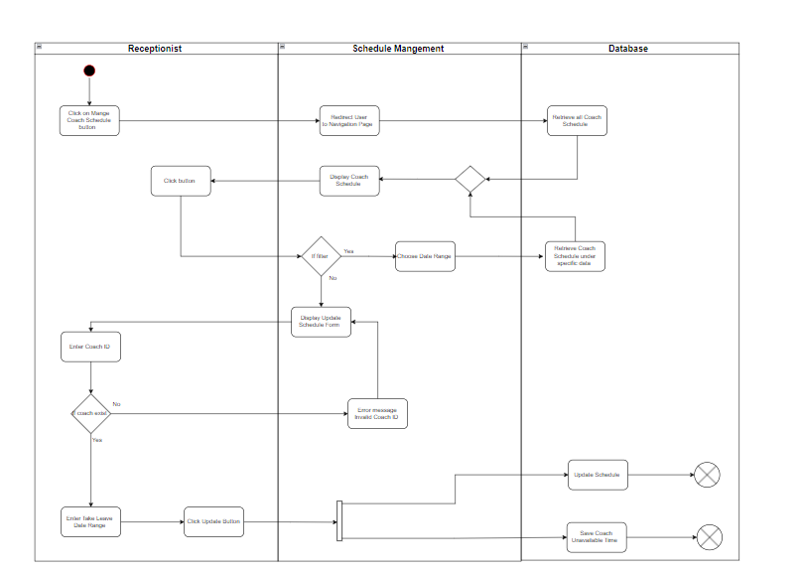

Figure 45: Manage Coach Schedule Activity Diagram

When a receptionist selects the Manage Coach Schedule Button, the system redirects the receptionist to the navigation page, where all coach schedules are retrieved from the database and displayed. If the receptionist wishes to modify the date range for Coach, he or she may do so by clicking the filter option and selecting a different data range. After modifying the date range, the database will retrieve and show the new date range for the coach schedule. If the receptionist chooses not to change the date range, he or she can input any coach id, select a on leave date range, and click the update button to save the information in the database. If the coach id does not exist an error message will appear indicating that the coach ID does not exist redirect the receptionist back to display update schedule form. The database will then update the schedule and record the times when each coach is unavailable. This allows the system to determine which coaches are unavailable at a certain time or day before showing the updated schedule for coach.

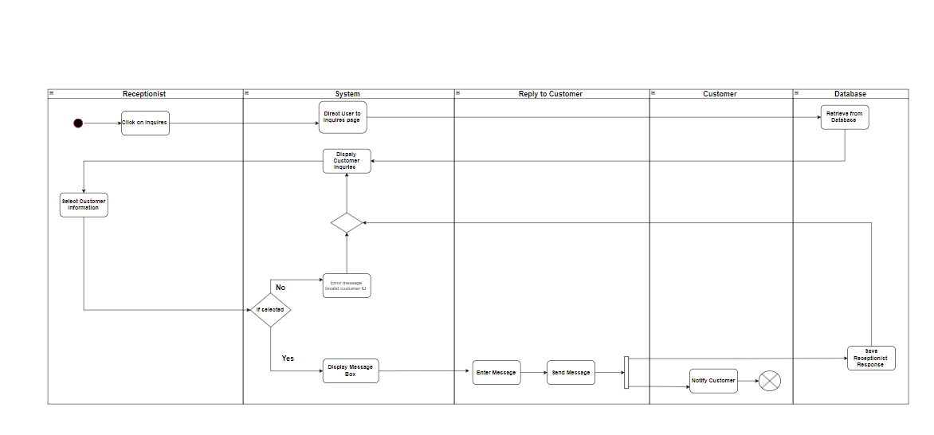

Figure 46: Reply Customer Inquiry Activity Diagram

When a receptionist needs to respond to customer inquiries, they can simply click on the "Inquiries" page. This will direct the system to retrieve and display the customer inquiries from the database. Once the inquiries are display, the receptionist can choose a specific customer to reply to. Upon choosing a customer, a message box appears, allowing the receptionist to type and send a response. If the customer ID does not exist, then the system will display an error message. After sending the message, the customer will receive a notification and the receptionist's response will be saved in the database.

### 8.5.2 Rapid Application Development (RAD)

TheRapid Application Development (RAD) is very useful for Junior Football Academy Malaysia Centre because Rapid Application Development (RAD) is a dynamic software development methodology based on flexibility and customer feedback. The emphasis on early prototypes and testing over time differentiate RAD from the waterfall model's methodology. RAD's customer focus makes it ideal for projects that require UI & UX, short release cycles, tight budgets, and rapid development (Sooni, 2023).They are total of (5 phases in RAD) which is Business Modelling, Data Modelling, Process Modelling, Application Generation and Testing and Turnover.

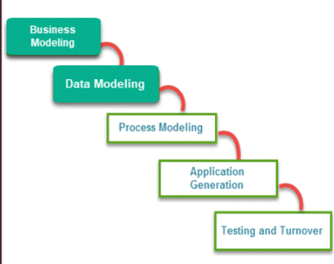

Figure 47: RAP Model

**Phase-1: Business Modeling**

The Junior Football Academy Malaysia Center's analytical team will gather information on player records, football training schedules, manual appointment scheduling, booking techniques, training records, and billing procedures in the first phase. This serves as the foundation for understanding the old system and improving further. In addition, our analytical team in Junior Football Academy Malaysia Center's will interact with stakeholders to gather information about their requirements and areas of dissatisfaction with the previous system. The purpose of this is to get feedback from skateboarders, as their views are vital for improving the old system.

**Phase-2: Data Modeling**

During the first phase, the Junior Football Academy Malaysia Center's analytical team gathers detailed information on player records, football training schedules, manual appointment scheduling, booking processes, training records, billing procedures, and feedback from feedback. Following that, the Data Modeling step involves the team cautiously analyzing the information and categorizing it based on its significance and benefit to the company. This strategic data grouping establishes a structure towards the establishment of an organized and ordered foundation that will guide the system development process. By recognizing the value of each piece of information and organizing it efficiently, the Data Modeling phase guarantees the following phases of the information system deployment adapt to the specifics needs of the organization.

**Phase-3: Process Modelling**

For this phase 3, all the gather information from the phase 2 are converted to useful data that will help the Junior Football Academy Malaysia Center's improve the old system. Through this transformation process, the collected information is organized into a structure that is suitable with the requirements and features of the Junior Football Academy Malaysia Center's operations.

**Phase-4: Application Generation**

In phase 4, the information that is gathered is coded into real life. This is to build a system to replace the outdated system at the Junior Football Academy Malaysia Centre. In addition, our team also created a prototype-based model for the system to serve a solid foundation. Furthermore, the date models that are created during phase-3 we be turned into actual prototypes that can be tested in the next phase.

**Phase-5: Testing and turnover**

In the last phase, our team will prioritize the prototypes by minimizing the duration of testing time. Our team will ensure that each model is tested separately, which makes it easier to identify parts that need to be modified and creates a reliable and efficient product for the Junior Football Academy Malaysia Center.

**(RAD) Advantages**

**1.Iterative Model:**

* The iterative approach of RAD allows continuous improvement with a small team, fostering flexibility to change the system requirements.

**2.Measurable Progress:**

* RAD offers simplicity, which enables easy tracking of project progress

**3.Reduced Time for production periods :**

* By prioritizing fast modifications, RAD significantly reduces production periods, which leads to rapid and efficient system evolution.

**4.Short Iteration Time:**

* Because of RAD flexibility tools, it allows short iteration cycles, resulting in fast analyses and modifications while increasing overall project efficiency.

**5.Quick Initial evaluations:**

* The RAD framework promotes rapid feedback and early tests, resulting in an interactive development environment.

**(RAD) Disadvantages**

**1.Rushing the Implementation of the Project:**

* The quick pace of RAD may result in an error of the system, which reduces the overall accuracy of the project planning and implementation.

**2.Loose Documentation:**

* RAD's focus on prototypes could oversee documentation, affecting long-term system understanding.

**3.Not Suitable for long –Term Tasks:**

* While RAD is successful for short-term projects, it may struggle to manage longer or more complicated developments.

**4. Takes much effort learning RAD tools:**

* Beginners may have difficulty using RAD tools, because it requires more effort and time to gain the skills.

**5.Skill Requirements:**

* Because RAD relies on rapid development cycles, it requires an experienced team, which increases the need for experienced developers and designers.

**6.Management Complexity:**

* The quick and iterative process of RAD can lead to management complexity, requiring a well-coordinated skilled team to properly handle potential issues.

### 8.5.3 Reliability Testing

**Justification:**

1.Reliable Performance:

Testing for reliability ensures that when a receptionist updates a coach schedule or replies to a customer inquiry, the system does these tasks smoothly and efficiently.

2.Avoiding Mistakes:

Reliability testing catches and fixes errors, like handling an invalid coach ID or modifying date ranges for coach schedules. When a receptionist replies to a customer, it makes sure things go smoothly, avoiding mistakes in the process.

3.Easy to Use

Reliability testing is like making sure a tool works the way you expect it to. For tasks like modifying date ranges for coach schedules, it guarantees the system shows the right information making it easy to use.

4.Maintaining good records:

When updating coach schedules, reliability testing ensures that the system keeps accurate track of when a coach is unavailable. Similarly, when a receptionist responds to a customer, the system ensures that everything is properly recorded.

5.Dependable   System:

 Reliability testing makes the system more trustworthy. When a receptionist monitors coach schedules or replies with a customer, you can be confident that the system will not produce unexpected mistakes, making it a dependable and trustworthy tool for everyday tasks.

Summary

In a nutshell reliability testing ensures that important system activities, such as maintaining coach timetables and replying to customer inquiries, run consistently and smoothly. It eliminates mistakes, promotes a user-friendly experience, ensures accurate record-keeping, and promotes trust in the system's dependability for everyday tasks.

Test Script : (Manage Coach Schedule )

|  |  |  |  |  |  |  |
| --- | --- | --- | --- | --- | --- | --- |
| Test Case | Test Unit | Test Procedures | Test Data | Excepted Result | Actual Result | Status |
| TS001 | Manage Coach Schedule Button | 1. Click on "Manage Coach Schedule" button. 2. Check if redirected to the navigation page. | N/A | Navigation page for managing coach schedules displayed. | Redirected to the navigation page. | Pass |
| TS002 | Coach Schedule Retrieval | 1. Navigate to Manage Coach Schedule Page. 2. Verify coach schedules retrieved and displayed. | N/A | Coach schedules retrieved from the database are displayed | Coach schedules displayed successfully. | Pass |
| TS003 | Filter Option for Date Range Modification | 1. Navigate to Manage Coach Schedule Page. 2. Click on filter option. 3. Select a different date range. | New date range | Database retrieves and displays coach schedules for the new date range. | Coach schedules for the new date range are displayed. | Pass |
| TS004 | Updating Coach Schedule with Date Range | 1. Navigate to Manage Coach Schedule Page. 2. Click on filter option. 3. Modify data range.   Input coach ID, on- leave date range and click update. | Coach ID and on-leave date range | Database updates coach schedule and records times when coach is unavailable. | Coach schedule updated successfully with the modified date range | Pass |
| TS005 | Updating Coach Schedule with  Invalid Coach ID | 1. Go to Manage Coach Schedule Page 2. Input a invalid coach ID. | Invalid Coach ID | The system should display an error message indicating invalid coach ID. | Error message displayed for an invalid coach ID. | Pass |

Test Script: (Receptionists reply to customer inquiry)

|  |  |  |  |  |  |  |
| --- | --- | --- | --- | --- | --- | --- |
| Test Case | Test Unit | Test Procedures | Test Data | Excepted Result | Actual Result | Status |
| TS001 | Inquiries Page Navigation | 1. Click on the "Inquiries" page. | N/A | The system should navigate receptionist to the inquiries page | Successfully navigate receptionist to the inquiries page | Pass |
| TS002 | View Inquiries on the Inquiries Page | 1. Go to the "Inquiries" page. | N/A | The system should retrieve and display customer inquiries from the database. | Customer inquiries are displayed on the Inquiries page. | Pass |
| TS003 | Reply to a Customer Inquiry | 1. Navigate to the Inquiries page. 2. Choose a customer to reply to. 3. Type and send a response in the message box. | Choose customer and Response message | The customer should receive a notification, and the receptionist's response should be saved in the database. | Response sent successfully and response recorded in the database. | Pass |
| TS004 | Reply to invalid customer ID | 1. Navigate to the inquiries page. 2. Input an invalid customer ID. | Invalid customer ID | The system should display an error message, indicating that the customer ID does not exist. | Error message displayed for an invalid customer ID. | Pass |
| TS005 | Verify Notification after Receptionist Reply to Customer | 1. Send a response to the   Customer.   1. Verify if customer received notification. | N/A | The customer should receive a notification.  after receptionist reply | Notification received by the customer | Pass |

# 8.0 References

(M.), M. (1 August, 2017). *Personal | FPX*. Retrieved from PayNet: https://www.paynet.my/personal-fpx.html

GeeksforGeeks. (21 December, 2023). *Spiral Model Software Engineering*. Retrieved from GeeksforGeeks: https://www.geeksforgeeks.org/software-engineering-spiral-model/

Google. (7 April, 2008). *Cloud Storage*. Retrieved from Google Cloud: https://cloud.google.com/storage?hl=en

Google. (1 January, 2019). *ChromeOS features - Google ChromeBooks*. Retrieved from Google ChromeBooks: https://www.google.com/chromebook/chrome-os/

HackerOne. (n.d.). *HackerOne*. Retrieved from What Is Security Testing?: https://www.hackerone.com/knowledge-center/what-security-testing

Hamilton, T. (16 December, 2023). *Guru99*. Retrieved from Stability Testing in Software Testing: https://www.guru99.com/stability-testing.html

Janse, B. (8 October, 2019). *The Rational Unified Process Methodology (RUP)*. Retrieved from Toolshero: https://www.toolshero.com/information-technology/rational-unified-process-rup/

Kanjilal, J. (7 December, 2022). *Introduction to Rational Unified Process (RUP)*. Retrieved from developer.com: https://www.developer.com/project-management/rational-unified-process-rup/

Laoyan, S. (12 January , 2022). *Everything you need to know about waterfall project management*. Retrieved from asana: https://asana.com/resources/waterfall-project-management-methodology

Lewis, S. (9 June, 2023). *Definition prototyping model*. Retrieved from TechTarget: https://www.techtarget.com/searchcio/definition/Prototyping-Model#:~:text=The%20prototyping%20model%20is%20a,or%20product%20can%20be%20developed.

Sooni, S. (31 March, 2023). *LogRokcet*. Retrieved from What is rapid application development (RAD)?: https://blog.logrocket.com/product-management/what-is-rapid-application-development-rad/

Sumon, N. (17 November, 2023). *Prototyping: Types, Benefits, and Best Practices*. Retrieved from linkedin: https://www.linkedin.com/pulse/prototyping-types-benefits-best-practices-nurnabi-sumon-cmqvc?trk=article-ssr-frontend-pulse_more-articles_related-content-card

T, W. (23 March, 2023). *All Advantages and Disadvantages of Prototype Model*. Retrieved from biplus: https://biplus.com.vn/advantages-and-disadvantages-of-prototype-model/

Taylor, D. (5 August, 2022). *A Step-by-Step Guide to the Rational Unified Process*. Retrieved from The ascent: https://www.fool.com/the-ascent/small-business/project-management/articles/rational-unified-process/

Team, I. E. (4 February, 2023). *A Complete Guide to the Waterfall Methodology*. Retrieved from indeed: https://www.indeed.com/career-advice/career-development/waterfall-methodology

Teams, A. C. (18 March, 2022). *Waterfall Methodology: A Complete Guide*. Retrieved from Adobe Experience Cloud: https://business.adobe.com/blog/basics/waterfall

Walton, E. (10 December, 2023). *Benefits of Prototyping*. Retrieved from Visily: https://www.visily.ai/blog/benefits-of-prototyping/#:~:text=Prototyping%20puts%20the%20user%20at,easy%20and%20fun%20to%20use.

Webitlab. (13 September, 2023). *Prototyping : Challenges & Solutions*. Retrieved from linkedin: https://www.linkedin.com/pulse/prototyping-challenges-solutions-web-it-lab

*What is Load Testing?* (n.d.). Retrieved from opentext: https://www.opentext.com/what-is/load-testing